A Guide to planning and reporting your interventions
In order for you to gain your GHLL award you need to complete the GHLL Review of the health and wellbeing provision, policy and practice in your school and also a minimum of two interventions.
For the Healthy Schools award, at least one intervention must have a mental health focus. For the Mental Health Champions award both (or all if doing more than two) interventions must have a mental health focus.
Needs analysis
Your interventions must be tailored to meet the needs of the children/ young people in your setting. On the online tool there is a drop down box for you to select what data you looked at to find out the need (e.g. Pupil Wellbeing Survey, school based survey, attendance records for after school clubs etc) as well as a free text box for you to explain what your needs analysis told you and why you then selected the outcome.
Choosing your participation group
Obviously, your participation group should be the group who need the intervention the most although practical factors also need to be taken into consideration. Some interventions will be whole school, some with a single key stage, year group, class and some will be with a small group of targeted pupils.
Ideally at least one of your interventions should be large scale i.e. whole school, whole key stage or, in larger settings, a whole year group. Within this large group it is good practice to identify a target group of pupils for whom the outcome will be of particular relevance in terms of their need. E.g. You may initiate the Daily Mile with the whole school but within the whole participation group you may identify a small group of pupils who do not do take part in any physical activity in school other than in PE. The intervention will benefit all pupils but be particularly beneficial to this target group. On the planning and reporting tool you will need to state who your target group are and why they were chosen. [NB LTs: this refers to a new box that we will be adding]
Look at this example:
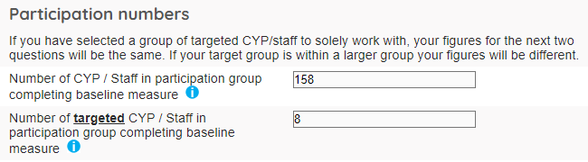
Here, the school has identified a target group of 158 pupils, of which 8 pupils are their target group.

Alongside your large-scale intervention, you may also wish to run an intervention with a small group of pupils. This may be a group who need to develop positive social skills, are consistently bringing unhealthy lunches, need to develop resilience etc. This group may receive more intensive 1-1 or small group input during the intervention.
Please note that if you have a small target group as one of your interventions then the numbers of the whole group and the target group will be the same when completing the data on the interventions page.
On the planning and reporting tool there is a drop-down menu which you can use to select all the criteria that apply to your participation group e.g. whole school, KS2, C&YP with behavioural difficulties, C&YP with low self-esteem etc.
Baseline measure
You will need to enter the number of pupils who undertake the baseline measure. This must be the same pupils who will go on to complete the final measure. For example, if you do the baseline measure with 90 pupils but two pupils leave before the final measure then you can only report on the 88 pupils who completed both the baseline and final measure.
How you measure the progress pupils make is up to your professional judgment as measurement techniques will vary according to the outcome you are working towards. For example, if your outcome is about increasing the number of pupils who are bringing healthy snacks to school then you can do a simple count of pupils who are doing this at the start and end of your intervention. If, however, your outcome is about developing resilience you may use a simple survey with pupils where they (or you) rate on a scale or 1-5 or 1-10 how much they/you agree with a set of statements about their resilience.
NB See appendix for sample measurement surveys.
There is a drop-down menu where you can select the type of measurement technique/s that you are using in your intervention. There is also a free text option where, if necessary, you can add your own measurement technique.
Progress and significant progress
You will also need to define how you differentiated between pupils who made any progress and pupils who made significant progress. [NB LTs: this is another new box we are adding to the interventions page] For example, if your outcome is about pupils who can identify and communicate the Five Ways to Wellbeing you may decide that pupils who make any progress are those who can name the Five Ways whereas significant progress would be those who can give a clear explanation of the benefit of each of the Five Ways. Teacher observation can be an important factor in helping to determine those pupils who have made significant progress (e.g. observed behavioural change in relation to the outcome).
It is essential that you know how you are going to measure progress at the start of your intervention. If this is in place then everything else falls into place. N.B. Keep your measurement techniques as simple and manageable as possible.
Running your intervention
Once you have completed your baseline measure you can now run your intervention with the selected participation group. This may be in lesson time, through extra-curricular clubs, via the school council etc. In your commentary it is really helpful if you can give a clear and comprehensive narrative of how your intervention was run.
Impact of the intervention
There is a free text box where you can note the qualitative data of your intervention’s impact. You may include quotes from staff or pupils and detail behavioural change you may have noticed.
If you are talking about numbers of pupils then please avoid using percentages but actual numbers e.g. ‘15 pupils are now continuing to attend the after-school club’ rather than ‘67% of the group have continued to use the after-school club’. Again, a clear and comprehensive commentary is helpful here.
Progress numbers
If you have clearly planned your measurement methods at the outset then this should be simple to complete.
Basically, you need to report on:
- The total number of the participation group who have made any progress
- The total number of pupils who have made significant progress (if you have clearly defined significant progress above at an early stage then this should present no problem). Please note that this figure is a sub-set of the whole participation group.
You will also need to report the progress numbers for the target group. Remember, the target group is a sub-set of the whole participation group.
NB If your whole group is the small target group then the numbers will be the same for both sets of figures.

Look at the following example:
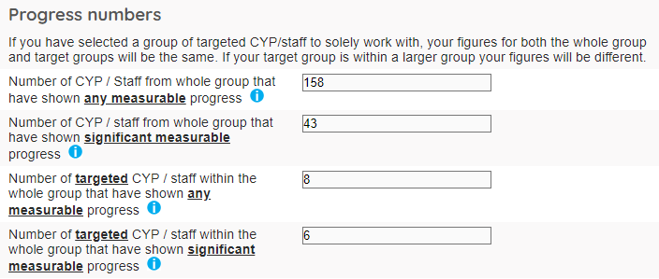
Here the school has measured progress and found that all 158 pupils had made some progress and therefore so had all of the 8 target pupils.
The school had also clearly defined significant progress and found that 43 of the 158 pupils had made significant progress. 6 of the 8 target pupils had also made significant progress.
Next steps
The ‘next steps’ box is a chance for you to explain what you will do now your intervention has been completed. There are usually three main things you might wish to comment on here:
- If your intervention was successful, will you continue with it – perhaps with another participation group? Or in the following academic year?
- If your intervention was successful, what will you do to build on the work you have done?
- What will you do for pupils who did not make the progress you had hoped for? What will you provide for them so that they are still supported in working towards the outcome?
Archive
Once you have been given your GHLL Healthy Schools or Mental Health Champions award you can now archive the interventions you used by checking the box next to ‘Archive’ and saving. Your old interventions are stored in an archive folder which you can access at any point.
And finally…
Hopefully the above guidance has been useful in helping you to plan, run and report your interventions but if you have any queries or get stuck on anything then please do not hesitate to contact your assigned GHLL Lead Teacher who will be happy to assist.
May 2020

