This intervention uses the **‘5 ways to wellbeing’**, it **improves the knowledge and understanding** of staff and pupils in this area and ultimately, **changes the behaviours** of the pupils in the 5 ways at break time and lunch time.

**Story of improvement**

**POSITIVE PLAYTIME PRACTICE**

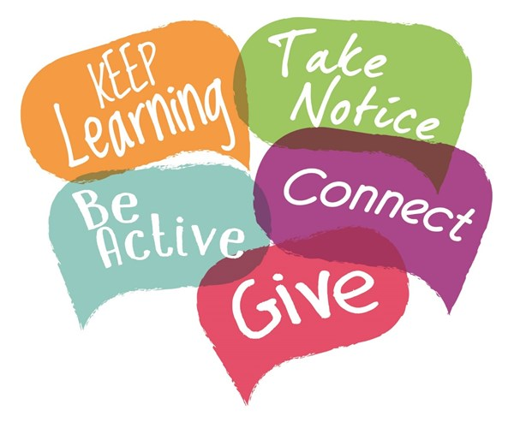

**Step 2:** THE ACTION PLANNING TEAM (IN THE PLAYGROUND)

A group of 10 pupils from Year 5/6 then use the outcomes from the human bar chart to plan activities for playtime and lunchtimes that engage more children in the target areas from the 5 ways to wellbeing.

An action plan is generated as a result of this planning group work.

**Step 3:** THE TARGET GROUP (IN THE STAFFROOM)

A meeting I then set up with MDSV and TAs who are on duty at playtime and lunchtime.

We then chose a group of 6 pupils to focus on for the first 6 weeks of the practice. These pupils are targeted because they are isolated, poorly behaved, attention seeking, etc.

We use the 5 ways to wellbeing to plan additional engagement opportunities just for them. This targeted plan of action is then worked on every break time by everyone on duty.

**Step 1:** THE ELICITATION AND BASELINE ASSESSMENT (IN THE CLASSROOM)

What we are currently getting at break and lunchtime?

Pupils use De Bono’s hats to investigate current playtime issues and solutions.

Pupils then undertake a human bar chart activity to find out what they know about wellbeing and how they are currently leading their lives in line with the ‘5 ways to wellbeing’. This highlights current good behaviours against the 5 ways, but also highlights where behaviours are not so good, and this is the step that points out the need for an intervention in an area.

**Step 4:** SETTING UP THE PLAYGROUND (WHAT CAN BE PUT IN PLACE?)

* Signs can be set up in the playground to highlight the 5 ways to wellbeing
* Playtime Wellbeing buddies can be set up to support their peers
* Equipment can be bought to engage pupils
* Sports leaders can be trained to support an increase in physical activity
* Trails and games can be set up to help pupils connect
* Check ins can be set up for pupils who feel low to then take more notice and do something to move their mood

(A wider range of ideas can be found on the GHLL website)

**The outcomes:** AFTER USING THE HUMAN BAR CHART AGAIN TO ASSESS IMPACT & FROM TALKING TO MDSV ABOUT THE TARGET PUPILS

Target pupils become more engaged at break time and lunchtime because we actually get to know them better and they enjoy the plans we have put in place for them.

The whole school can talk about wellbeing and pupils can share the activities they now take part in at break time and lunchtime to boost their wellbeing. Before this project they did not know what wellbeing was and what to do to give it a boost.

We repeated the human bar chart activity 12 weeks after putting in the PPP and we saw a change in behaviours for our target area, take notice. Pupils are now doing something positive to move their mood.