How do I look after my brain?

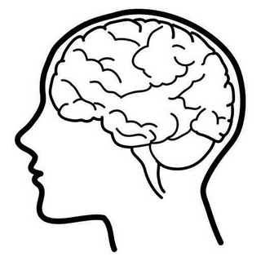
Draw pictures and label around the diagram to show what you need to do to keep your brain healthy.

