**Briefing on Vaping in Children and Young People in Gloucestershire**

**February 2023**

Vaping in Children and Young People in Gloucestershire:

* Whilst vaping is less harmful than smoking, and can be used to help people stop smoking, vaping is not for children.  The sale of cigarettes and nicotine containing vapes to under-18s is illegal.
* Gloucestershire’s Pupil Wellbeing Survey (PWS) is conducted every two years and asks pupils in years 4, 6, 8, 10 and 12+ a series of questions relating to their health and wellbeing.  Over half of pupils in the selected year groups responded, and they represent the majority of Gloucestershire’s primary, secondary, FE college, special and alternative provision schools.
* The prevalence of smoking amongst children and young people has declined over the period the survey has run. In 2012 89.7% of young people had never or not often (i.e. tried once or twice) smoked cigarettes; by 2022 this had risen to 95.0%.
* The chart below shows the proportion of pupils who report using nicotine regularly (either smoking or vaping) and how this has changed over the years that the survey was undertaken.

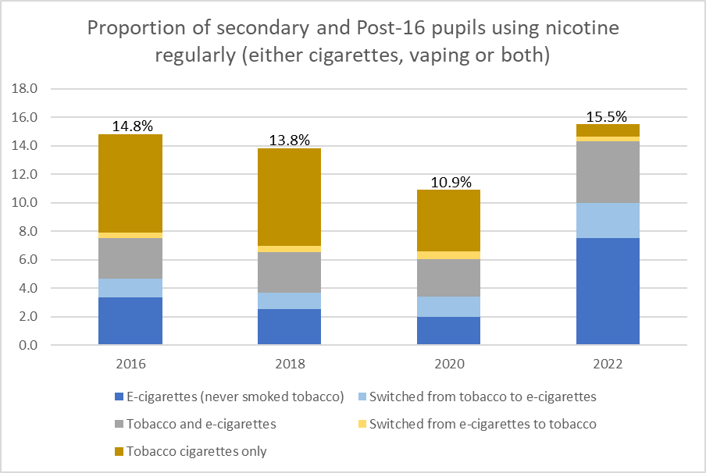

* The profile changed significantly between 2020 and 2022, with a large decline in the proportion of pupils reporting using tobacco, but a significant rise in the proportion reporting using e-cigarettes or a combination of the two.
* The total takes the proportion of young people using nicotine containing products above the 2016 level.
* There is evidence to suggest that the steep rise in e-cigarette use is a consequence of the availability and targeted marketing of disposable vapes[1].
* More information on vaping, including groups at higher risk of smoking and vaping, is available in the full report on [Health Harming Behaviours](https://inform.gloucestershire.gov.uk/media/2119487/health-harming-behaviours-v21.pdf) in children and young people.

Our local response:

* We are collaborating with partners across the South West on a Position Statement on Vaping which will summarise the current evidence base and priorities to address the issue.  This will include, for example, enforcement around the sale of vaping products, education and peer support for young people on the harms and risks, and the environmental impact of vaping.  This will be used by Gloucestershire’s Tobacco Control Steering Group to inform our action plan.
* Education around the harms and risks of smoking is part of the school RSHE curriculum.  Gloucestershire’s Healthy Schools Programme ([Gloucestershire Healthy Living and Learning](https://www.ghll.org.uk/toxic-tobacco-truths---secondary/)) provide lesson plans for primary and secondary age pupils to prevent smoking. Resources are regularly reviewed to ensure they reflect the current evidence base and emerging issues, which will include this observed rise in vaping.
* According to the PWS 2022, education programmes to prevent smoking appear to be seen as useful, the proportion of pupils reporting it was helpful to learn about smoking in school has increased from 69.5% in 2012 to 79.5% in 2022.

1. McNeill, A, Simonavičius, E, Brose, LS, Taylor, E, East, K, Zuikova, E, Calder, R and Robson, D (2022). Nicotine vaping in England: an evidence update including health risks and perceptions, September 2022. A report commissioned by the Office for Health Improvement and Disparities. London: Office for Health Improvement and Disparities.