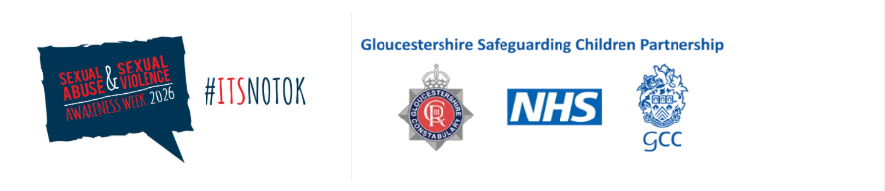

Text

📢 Sexual Abuse and Sexual Violence Awareness Week

Dear partners, as part of ‘Sexual abuse and Sexual Violence week’ (1/2/2026 - 7/2/2026), we will be sharing 5 key messages each day on Child Sexual Abuse (CSA) as part of our ongoing campaign to raise awareness as to the scale, nature and how we a partnership we should respond to CSA.

📅 Day 1

“I wanted them all to notice” - Understanding the Scale of CSA and Why Information Sharing Matters

The Child Safeguarding Practice Review Panel’s national review, I wanted them all to notice (2024), highlights that far more children experience sexual abuse than agencies currently identify. Understanding the true scale of harm is essential for partners across GSCP, because without this awareness—and timely information sharing—children remain invisible in plain sight.

According to the CSA Centre’s most recent review of evidence, at least 15% of girls and 5% of boys experience child sexual abuse before age 16. Other national estimates describe this as conservative, with some analyses suggesting up to 500,000 children experience sexual abuse in a single year across England and Wales.

Yet despite this scale, the proportion of children who actually tell someone at the time is extremely small. CSA Centre research shows that only 1 in 3 children abused by an adult tell anyone. Boys are less likely to tell than girls. Many children are unable to speak due to shame, fear, confusion, loyalty to family members, or simply lacking the language to describe what is happening.

This is why the Panel emphasises proactive, child-centred practice: professionals must notice, record, and share concerns early, even when they are uncertain. Relying on children reporting alone will always fail most children.

Over the coming days, we will share key messages to partners on how we can identify, respond communicate and how language used cam impact our response.

Text

