Text
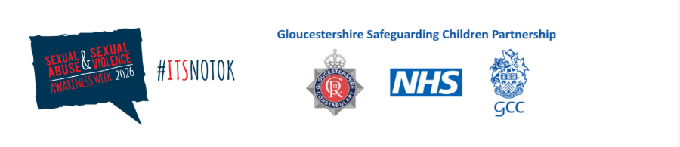

📢 Sexual Abuse and Sexual Violence Awareness Week

Text

📅 Day 3

The Response Pathway: A Shared Map From First Concerns to Protection and Support

The CSA Centre’s Child Sexual Abuse Response Pathway is a practical, step-by-step resource that sets out what to do and how to do it at key decision points—from first concerns and early help, through child protection, to criminal justice. It is designed to complement Working Together 2023, clarifying responsibilities and best practice so children’s needs, safety and voice stay central while partners coordinate action.

CSA Response Pathway >

Guide for Local Partnerships >

The Pathway has been piloted with local partnerships, with a dedicated implementation guide for areas introducing it at system level. It helps reduce drift, align thresholds, and standardise what good looks like across health, education, police, social care and the VCS.

In Gloucestershire: GSCP has prioritised strengthening our multi-agency response to CSA, working with the CSA Centre and NSPCC and is using the response pathway. Please do use this as a resource on what to do and how to do it when there are worries around CSA.

Text

