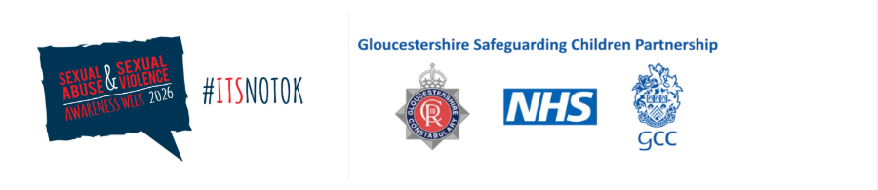

Text

📢 Sexual Abuse and Sexual Violence Awareness Week

Text

📅 Day 2

Spotting Concerns:
Using the CSA Centre Signs and Indicators Tool

Children rarely talk directly about sexual abuse; if they do this is unlikely to be to a professional, especially social workers. Research shows many children never report sexual harm at the time, and practitioners must rely on emotional, behavioural and physical indicators, plus contextual risk factors, to build a picture.

The CSA Centre’s Signs and Indicators template gives a shared language to record, discuss and share concerns across agencies.

Within the GSCP, we are currently piloting this tool to see how more broadly it can help as a partnership response to identifying and responding to signs and indicators of sexual abuse and we are working closely with the CSA centre around this.

Signs and Indicators Template >
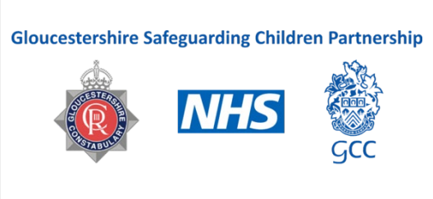

The template supports practitioners to triangulate:
- Child-level signs (e.g., marked behaviour change, anxiety, sexualised behaviour out of developmental expectation).
- Potential indicators in those who may be abusing.
- Environmental/family factors that increase opportunity and vulnerability. Collating patterns over time strengthens professional judgment and triggers timely information sharing with core partners.
This tool can be used creatively, within meetings around children, such as strategy meetings and should be used as a thinking tool, to consider concerns around sexual harm. It is best used collaboratively within a professional network to draw together the signs and indictors

Text

