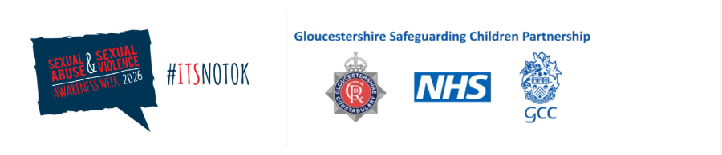

Text

📢 Sexual Abuse and Sexual Violence Awareness Week

Text

📅 Day 4

Language and Communication: Avoid “No Further Action”, and talk with children, not about them

Language shapes practice. Telling families or staff that a case is “No Further Action” (NFA) can imply “nothing happened” and may silence children, dissuade future help-seeking, or fracture multi-agency momentum. This may hamper our ability to have conversations and safety plan with parents around sexual harm. In reality, NFA often means no further criminal action at this time—not that safeguarding concerns are resolved.



Professionals should avoid using the term “No Further Action (NFA)” where there are child sexual abuse (CSA) concerns because it gives the false impression that concerns were unfounded or that a child is safe, when in reality NFA only means no further criminal action at that stage due to insufficient evidence for prosecution. It is also essential to understand that social-care decisions do not use the criminal burden of proof. Criminal cases require evidence beyond reasonable doubt, the highest standard. Safeguarding, however, operates on lower civil thresholds and balance of probabilities, allowing action when harm is suspected, not proven.

This is why partners should use precise wording (e.g., “no further police/CPS action at this stage”) and continue support, disruption and safety planning where concerns remain.

What We Need To Do:
Replace “NFA” in communications with accurate, child-centred phrasing and state what safeguarding actions continue (support, safety plan, monitoring, disruption).

Text

