Coronavirus Support for Young People

The outbreak of coronavirus and self-isolation has been difficult for many young people. If you are struggling, we understand and are here to help.

Click here to access our free COVID-19 mental health resources for teenagers, parents, teachers and health professionals. The resources are put together by Clinical Psychologist Dr Krause and will be regularly updated.

Click here to view a video message from stem4’s CEO.

stem4 is a charity that promotes positive mental health in teenagers and those who support them including their families and carers, education professionals, as well as school nurses and GPs through the provision of mental health education, resilience strategies and early intervention.
This is primarily provided digitally through our innovative education programme, pioneering mental health apps, clinically-informed website and mental health conferences that contribute to helping young people and those around them flourish.
A booklet for young people from stem4 (Secondary and colleges)
Worried about Coronavirus (COVID-19)? (By Dr Nihara Krause, Consultant Clinical Psychologist)
For all STEM 4 Resources including booklets and to download Apps please see link:
https://stem4.org.uk/

Returning to School Resources
TRAUMA INFORMED SCHOOLS UK - Return to School Training
https://www.traumainformedschools.co.uk/
COVID-19 is the very definition of A Traumatic Experience. Trauma is a response to any event/s encountered as an out of control, frightening experience that disconnects us from all sense of resourcefulness, safety, coping and/or love
There are many ways to reduce the rupture of emotional connection during social isolation, the following ideas have been compiled from many contributions from TIS UK trainers and practitioners across the country.

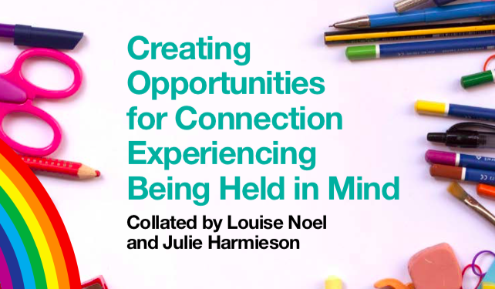
https://www.traumainformedschools.co.uk/images/TIS_Creating_Opportunities_2.pdf

