DEMENTIA DOG bandana
competition

Design a dog bandana on the template provided overleaf and submit your entry either electronically or hard copy.
Think about the following:
♦ Colour and contrast to support the changing brain of those with dementia
♦ Include a message e.g. reducing stigma and raising positive attitude about dementia
♦ Show dementia is not a natural part of aging
♦ It is possible to live well with dementia
♦ How we can all support someone living with dementia

REsults as follows: -
Key stage three: -

- Laura Davis 9s Ribston Hall High School
- Joshua Weaver 8C JAB Thomas Keble School
- harrybaker 8w jwh Thomas keble school

key stage two: -

- isabelle green Yr 5 Huntley Primary
- EMILY GODDING 6M BERKHAMPSTEAD SCHOOL
- MARYAM AMES YR 6 ELMBRIDGE PRIMARY SCHOOL

congratulations to Laura davis and isabelle green

Key stage three 1st, 2nd & 3rd

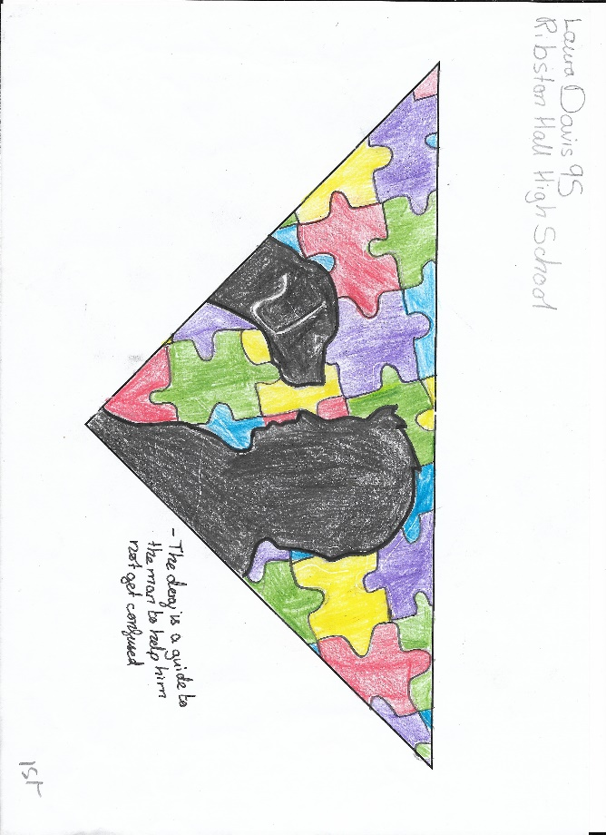
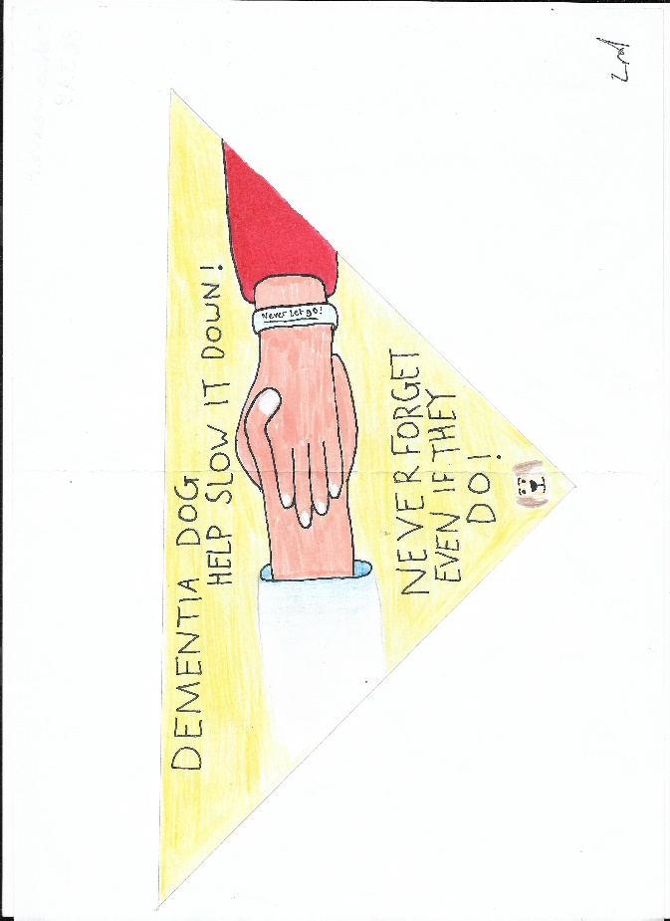
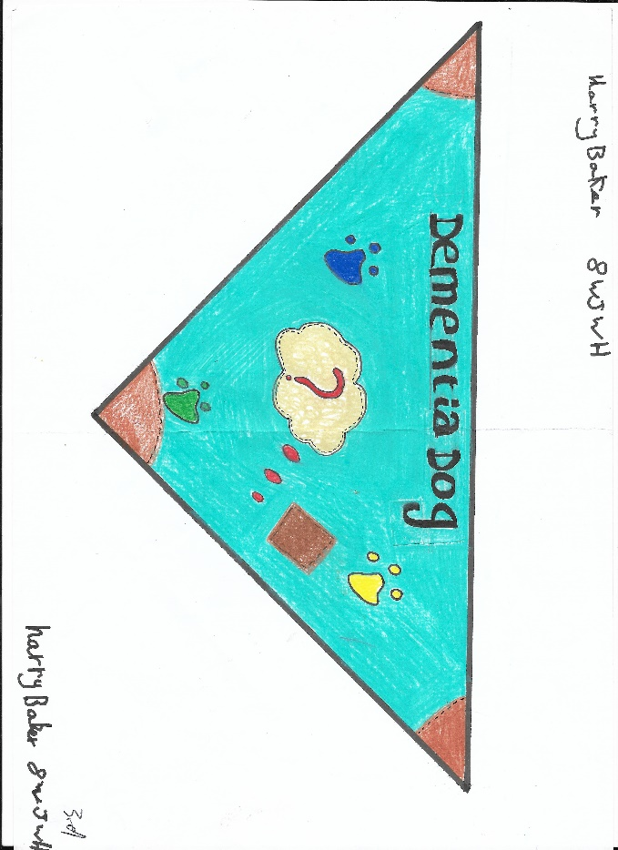

Key stage tWO 1st, 2nd & 3rd

