If you do not already have login details please request these by emailling Rachel.Howard@gloucestershire.gov.uk
If you previously had login details but can’t remember your password simply input your email adress and then click Don’t remember your password? And follow instructions.
Go to Pupil Inform website and type in your credentials followed by log on
www.Pupilinform.org
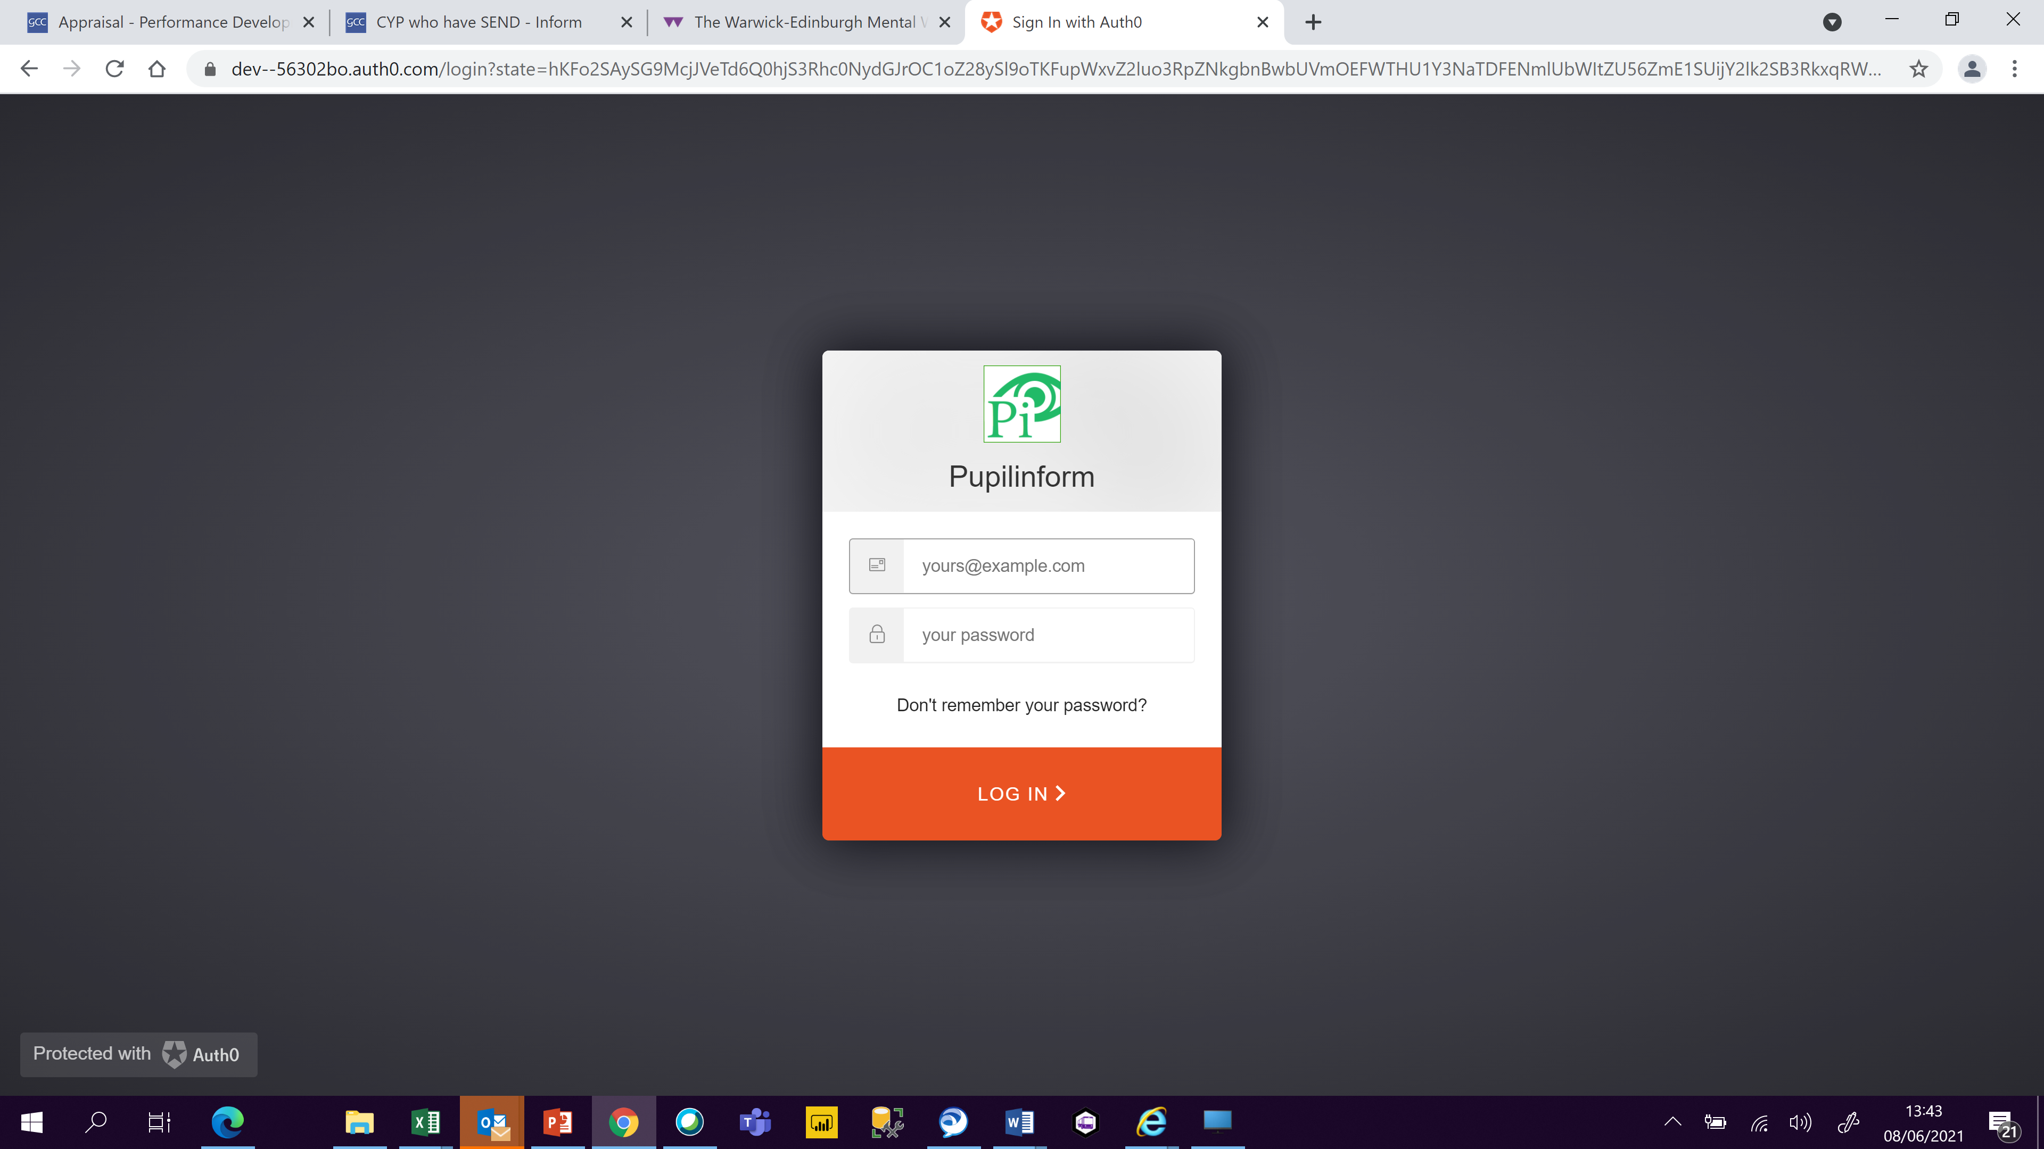

The page you will land on will look similar to this. On the right-hand side are your filter buttons that you can run a report from. The Geography box will automatically be populated with YOUR school, the Comparator filter will automatically show as Gloucestershire (whole county) but you can change this to compare with the district of your school or the statistical nearest neighbour group of your school if you would like.
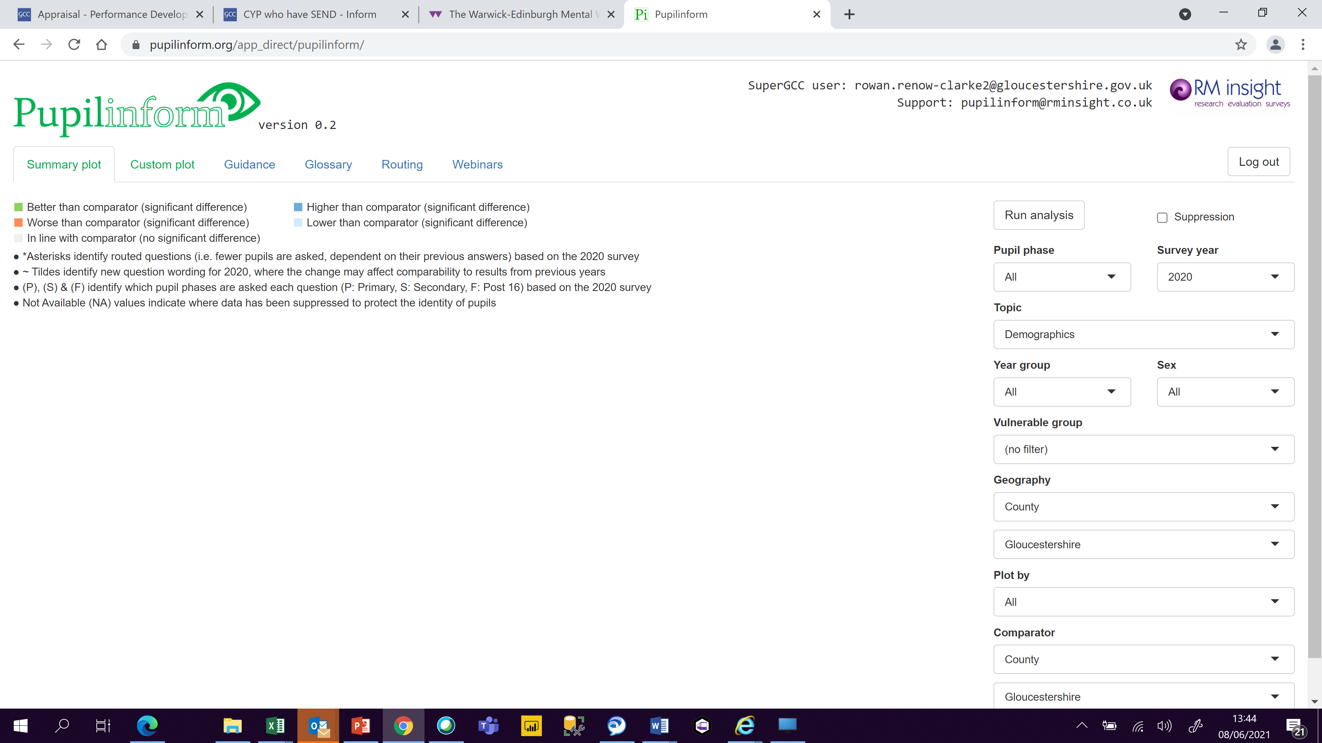
Once you have selected the comparator you want to use, click Run analysis. The results will then be shown on the screen as below
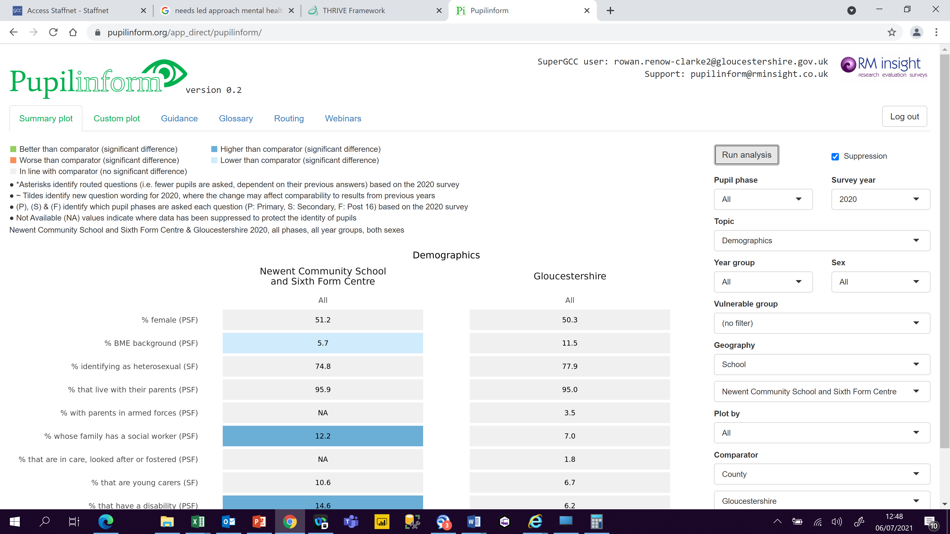
If you scroll down to the bottom of the page you will see 3 buttons that allow you to download the results – Download report (allows you to download the topic on the screen to a word document); Download data (allows you to download the data for this topic on the screen to an excel document); Download report (all topics) click this button to download the complete report of responses to all questions in the survey grouped into topics.
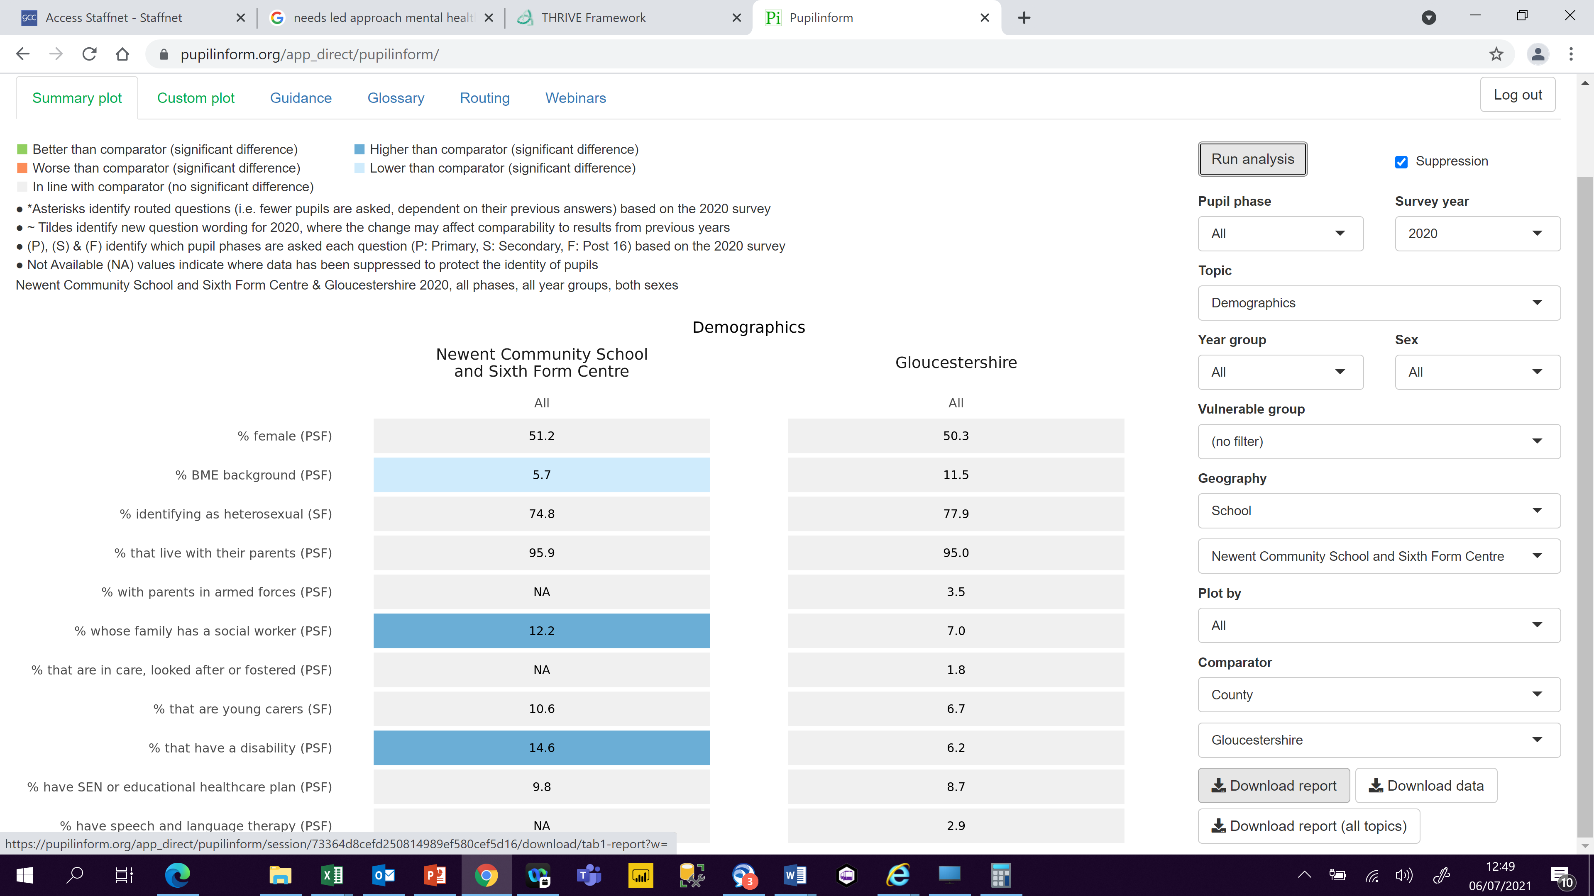
If required you can select other groups and download reports for each group such as a single year group, sex or vulnerable group by using the slicer and changing the comparator as desired. The example below shows the results for children classified as having low mental wellbeing in the school in comparison to those with low mental wellbeing in the district the school is in but you could compare this to the county population etc..
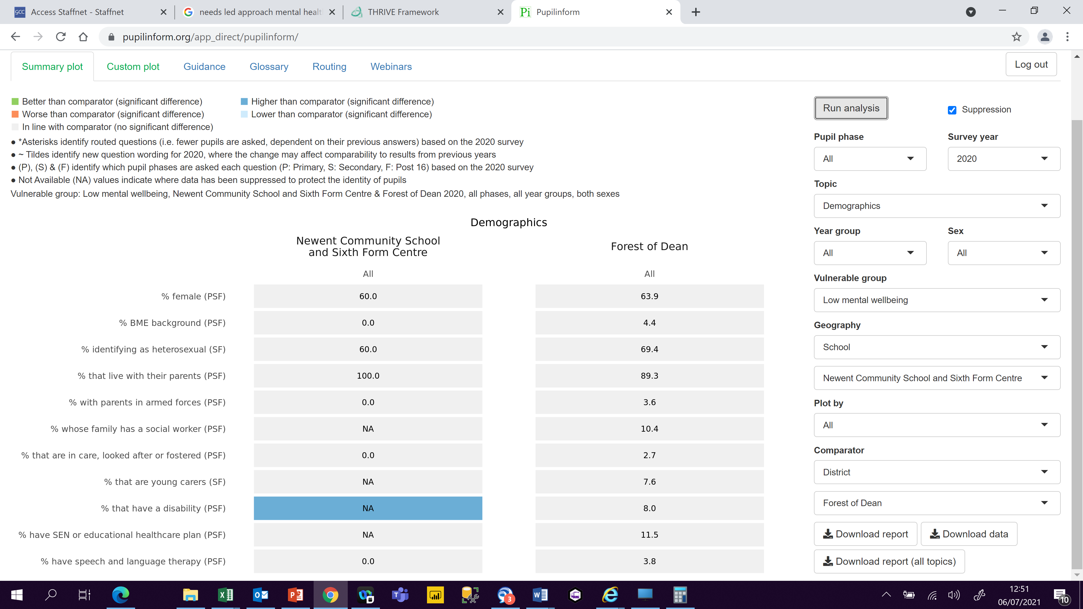

You can also look at longitudinal results for your school by changing the ‘Plot by’ filter to Survey year.
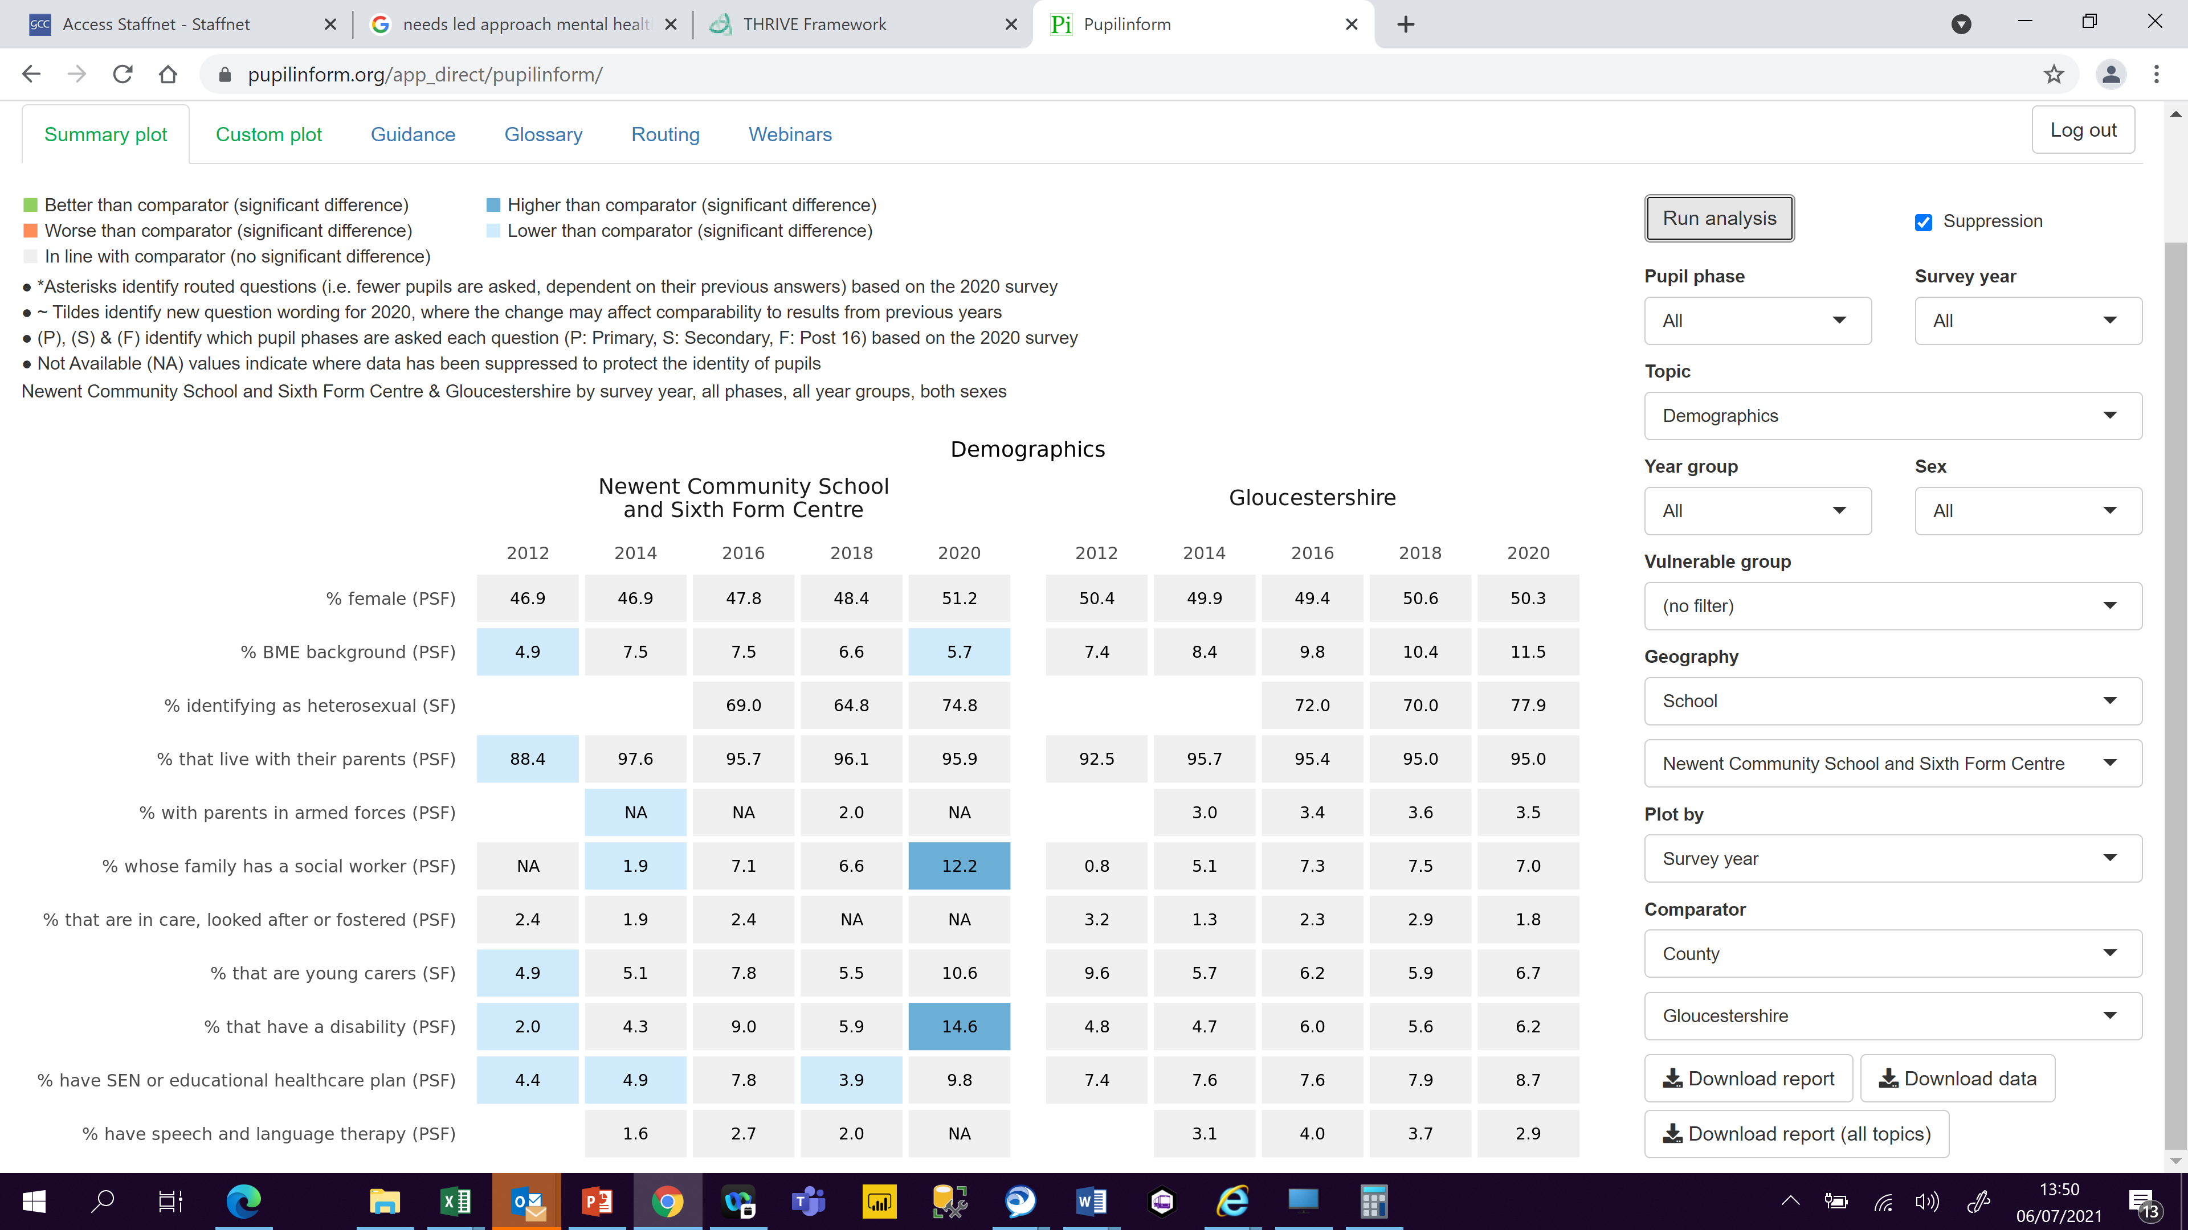
Or see all year groups at once
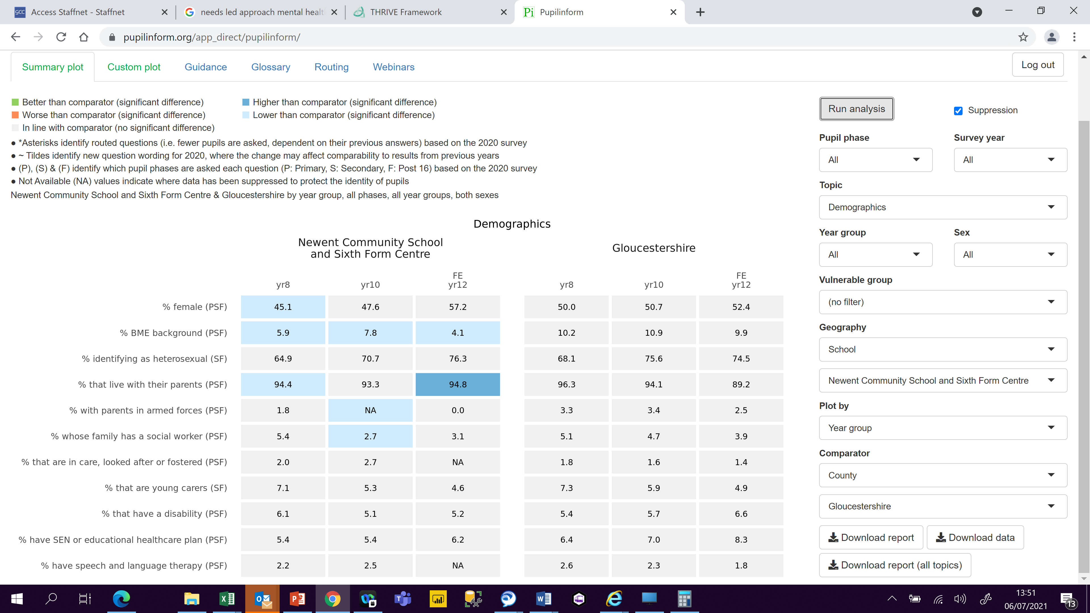
More detailed results for each question can also be seen by clicking the Custom plot tab on the top right of the screen. This will then give you the option of looking at a single question in isolation. You can type in a key word or phrase or choose from a list to find the question you would like.
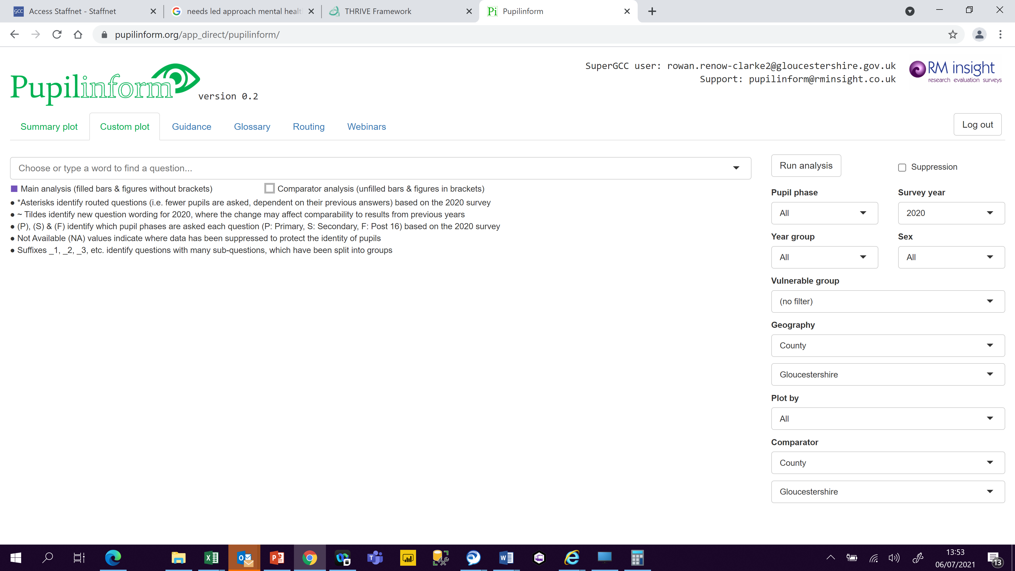
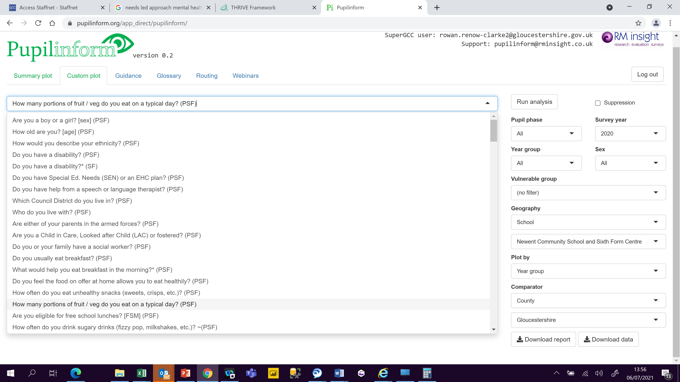
Select if you would like to limit the return by year group, sex, vulnerable group etc. and what you want to plot by and press Run Analysis. The results will then appear in a graph. Again, these can be downloaded by selecting one of the report buttons on the bottom right of the screen.
There are also OFSTED reports available, these have been created with the help of education colleagues to provide evidence for the inspection themes.
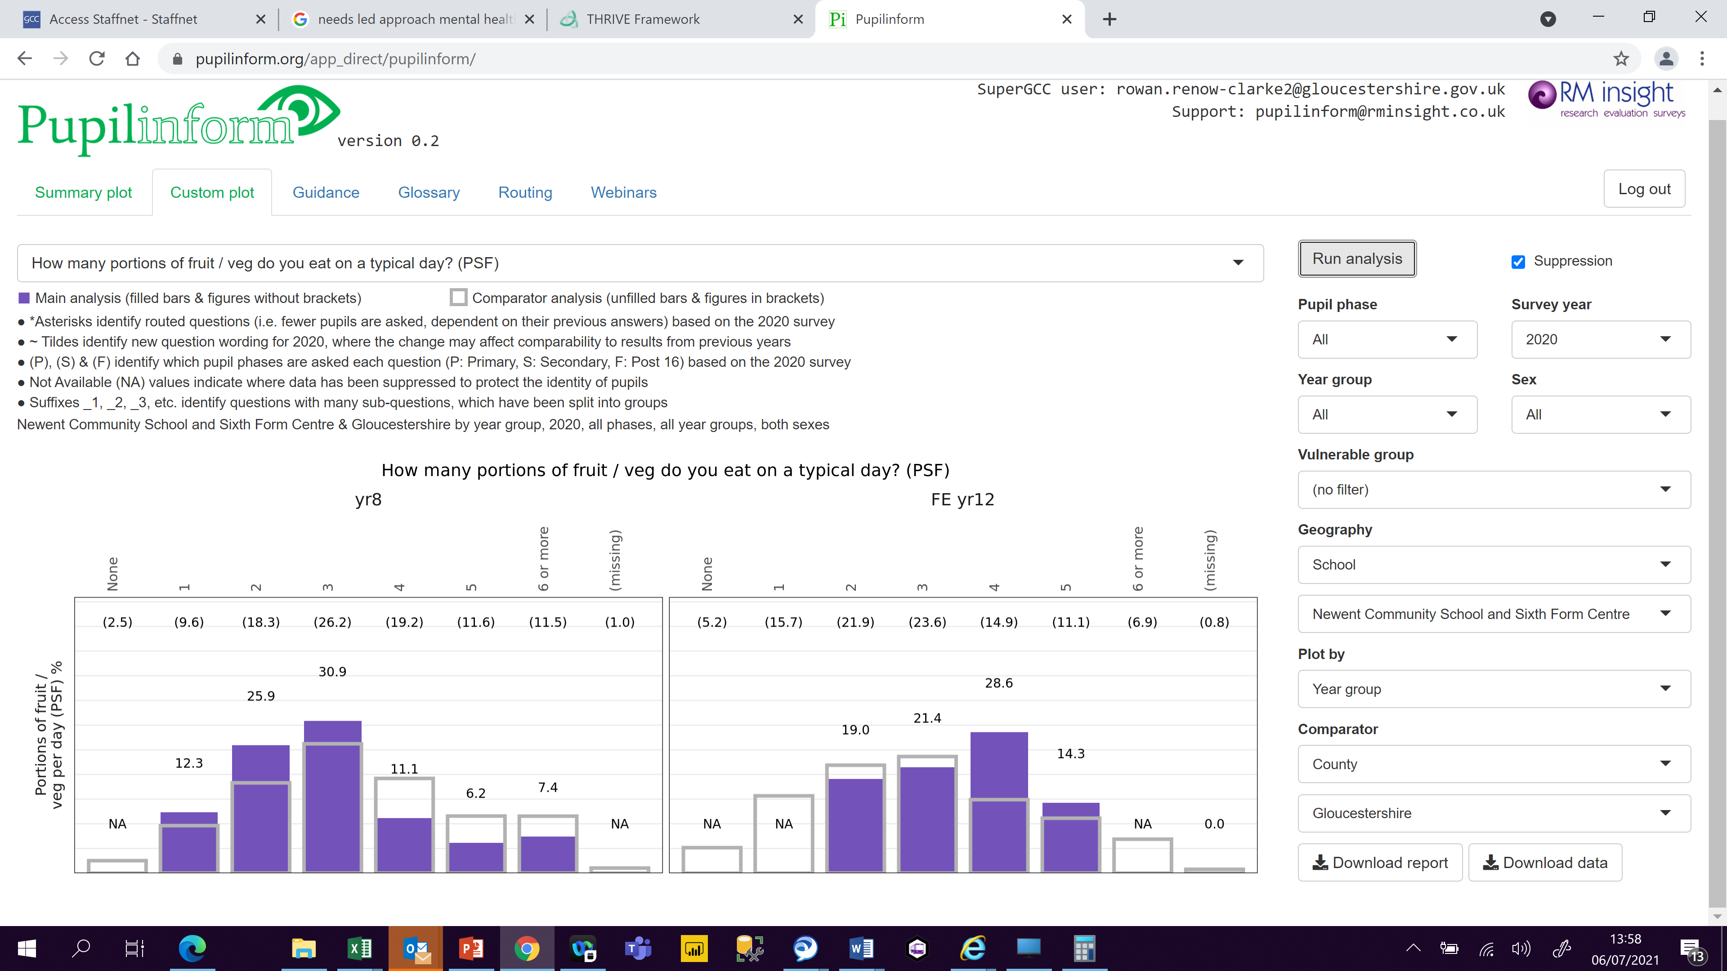
Fuller more detailed guidance can be found by clicking on the Guidance tab on the top right of the screen and those instructions can also be downloaded as a pdf for reference if required. The Webinar tab also provides a video to walk you through using the platform.
