STAKEHOLDER PROMOTIONS PACK
HEALTH UNCOVERED PODCASTS // SERIES 1
November 2017

Health Uncovered – Promotions Pack

We are engaging more young people in conversations about their health and wellbeing. You can help by using this pack of promotional materials to signpost to a new series of teen health podcasts. Following the introduction below, promotional materials begin on pg3.

What is Health Uncovered?
This is a unique innovation project, creating new ways for teenagers to engage with healthcare on their smartphones and other devices.  During 2017 we brought together broadcasting experts with healthcare professionals to make a series of magazine style round-the-table discussion shows that address key themes in teen health. | Ten audio shows, hosted by actor and BBC Radio 1 presenter Cel Spellman, have been delivered in partnership with NHS Trusts, healthcare charities and local authority partners. Each twenty minute programme deals with a different aspect of adolescent health, featuring the voices of staff and service-users from participating regions. They were co-designed with clinicians and young people, and are available to listen to on mobile devices, laptops and tablets.
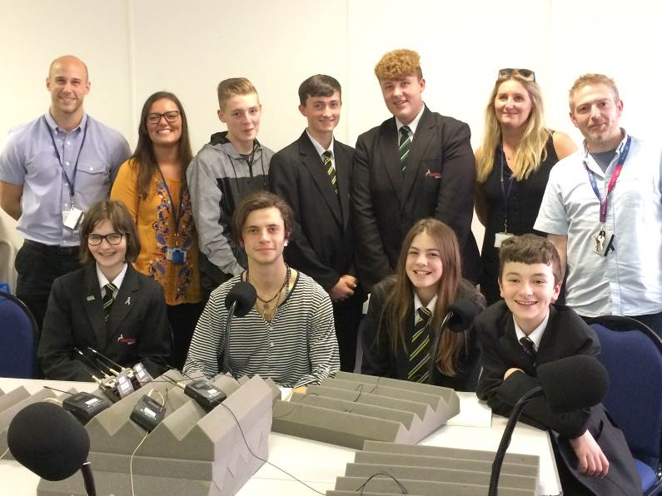
Series 1 - Episodes

#1 – Sexual health, STIs
#2 – Bullying, how it feels
#3 – Mental health, me and my emotions
#4 – Sexual health, are you ready?
#5 – Mental health, are you OK?
#6 – Grooming, could it happen to me?
#7 – Mental health, taking control
#8 – Mental health, asking for help
#9 – Social media, is this real life?
#10 – Substance misuse, know your choices

About the producers  Our production team makes iTunes-chart-topping audio podcasts which attract more than six million people listening each month. They work with the UK’s biggest music radio stations and some of the World’s best-recognized artists and DJs. | One in ten young people over the age of  15 listens to a podcast every week  They are more likely to listen to  podcasts than on-demand radio  Young people listen to nearly thirty hours of audio a week - more than other ages
Data Source - Rajar Midas Audio Survey 2016

WHAT’S IN THIS PACK?

Scroll down to find …

#1 Email Templates
Paste these in an email to your key contacts or people who will forward the information to young people, e.g. sending via the council to all schools with a request to forward to students, or colleagues who work with large groups of young people. When sending an email to a large database, putting the list of recipients’ email addresses in the BCC field will prevent accidental disclosure of personal details to the whole group.

#2 Webpage Information
Putting some information about Health Uncovered on your website along with our embeddable player will help your service users hear the podcasts more easily. It will also help improve the likelihood of your podcast’s details being found when “Health Uncovered” is typed into a search engine.

#3 Media Release Copy
Cut and paste copy which can be used for media releases or information releases to stakeholder organisations that you think might help promote the podcasts to young people, through their websites or printed publications.

#4 Trackable Links
Measurable links to specific “Health Uncovered” episodes for pasting into your bespoke communications materials.
Follow and interact with us on Social Media

TWITTER @HealthUncovNHS INSTAGRAM @healthuncovered

Email Template (HTML)
INTRODUCING OUR HEALTH UNCOVERED PODCASTS
With Cel Spellman

Our new series of podcasts hosted by BBC Radio One presenter and actor Cel Spellman aim to get more young people in-tune with their health and wellbeing.
Sexually transmitted infections, low-mood, self-harming, drugs, alcohol and everything else – Cel is lifting the lid on teenage health.

Life isn't always easy - and young people across the country have been helping us explore the issues that they’re facing today. From online bullying to sexual health, body image to mental health. They've been asking the questions you want to hear answered, joined by the health professionals that help young people, like school nurses and mental health specialists, to provide solutions, support and understanding.

LISTEN NOW
The podcasts are free and you can listen via mobile devices. Just search “Health Uncovered” in your favourite podcast app, like iTunes, or click below …

 | Health Uncovered – Series 1 | iTunes | Non-iTunes
 | #1 – Sexual health, STIs | iTunes | Non-iTunes
 | #2 – Bullying, how it feels | iTunes | Non-iTunes
 | #3 – Mental health, me and my emotions | iTunes | Non-iTunes
 | #4 – Sexual health, are you ready? | iTunes | Non-iTunes
 | #5 – Mental health, are you OK? | iTunes | Non-iTunes
 | #6 – Grooming, could it happen to me? | iTunes | Non-iTunes
 | #7 – Mental health, taking control | iTunes | Non-iTunes
 | #8 – Mental health, asking for help | iTunes | Non-iTunes
 | #9 – Social media, is this real life? | iTunes | Non-iTunes
 | #10 – Substance misuse, know your choices | iTunes | Non-iTunes
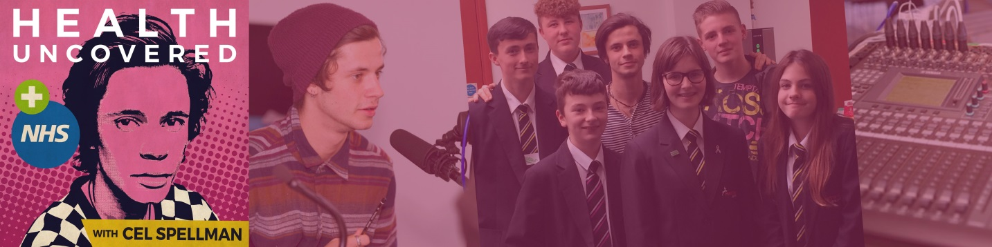
TWITTER @HealthUncovNHS INSTAGRAM @healthuncovered

PREPARING THIS EMAIL TO SEND IN OUTLOOK
Select the whole table above by clicking on the four-way arrow in the top left corner
Right click to select “copy”, then paste the entire main table above into an outlook email.
If this does not work easily for you, try selecting and deleting the grey background shape first.
Re-create the grey background in Outlook via “Options / Page Color”.
Check the email is centrally aligned, rather than aligned to the right or left
Test prior to sending with a single recipient.
Use the “BCC” rather than “To” or “CC” field for lists of multiple recipients.
Why not also include this document as an attachment so the recipient can help spread the word?
EMAIL TEMPLATE (TEXT)

INTRODUCING OUR HEALTH UNCOVERED PODCASTS
With Cel Spellman

Our new series of podcasts hosted by BBC Radio One presenter and actor Cel Spellman aim to get more young people in-tune with their health and wellbeing.
Sexually transmitted infections, low-mood, self-harming, drugs, alcohol and everything else – Cel is lifting the lid on teenage health.

Life isn't always easy - and young people across the country have been helping us explore the issues that they’re facing today. From online bullying to sexual health, body image to mental health. They've been asking the questions you want to hear answered, joined by the health professionals that help young people, like school nurses and mental health specialists, to provide solutions, support and understanding.

Listen now! The podcasts are free and you can listen via mobile devices, tablets and laptops. Just search “Health Uncovered” in your favourite podcast app, like iTunes, or click below …

Health Uncovered – Series 1 | iTunes | Non-iTunes
#1 – Sexual health, STIs | iTunes | Non-iTunes
#2 – Bullying, how it feels | iTunes | Non-iTunes
#3 – Mental health, me and my emotions | iTunes | Non-iTunes
#4 – Sexual health, are you ready? | iTunes | Non-iTunes
#5 – Mental health, are you OK? | iTunes | Non-iTunes
#6 – Grooming, could it happen to me? | iTunes | Non-iTunes
#7 – Mental health, taking control | iTunes | Non-iTunes
#8 – Mental health, asking for help | iTunes | Non-iTunes
#9 – Social media, is this real life? | iTunes | Non-iTunes
#10 – Substance misuse, know your choices | iTunes | Non-iTunes

High res logos in 5x colourways available on request
WEBPAGE INFORMATION

HEALTH UNCOVERED – OUR NEW SERIES OF PODCASTS
With Cel Spellman

Our new series of podcasts hosted by BBC Radio One presenter and actor Cel Spellman aim to get more young people in-tune with their health and wellbeing.
Sexually transmitted infections, low-mood, self-harming, drugs, alcohol and everything else – Cel is lifting the lid on teenage health.

Life isn't always easy - and young people across the country have been helping us explore the issues that they’re facing today. From online bullying to sexual health, body image to mental health. They've been asking the questions you want to hear answered, joined by the health professionals that help young people, like school nurses and mental health specialists, to provide solutions, support and understanding.

LISTEN NOW
[Paste this embed code into your CMS to insert our media player directly into your webpage]
<iframe height="250" width="630" src="http://thisisdistorted.com/channels/health-uncovered/?widgetMode=true”></iframe>

SUBSCRIBE THROUGH YOUR PODCASTING APP

To subscribe in your favourite podcasting app, like iTunes, just search “Health Uncovered” or click here:
iTunes // Non-iTunes

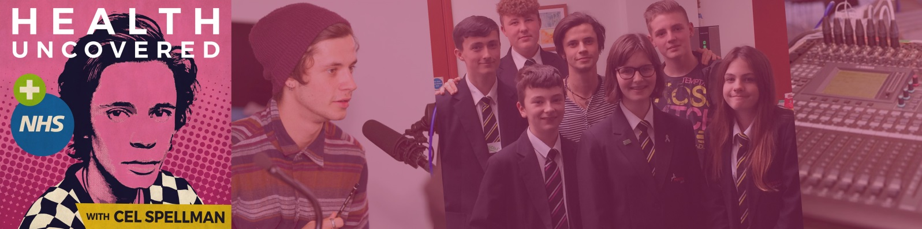

27 November 2017
MEDIA RELEASE
FOR IMMEDIATE ATTENTION
Radio DJ launches health podcasts for teens

A new series of podcasts aims to get more young people in-tune with their health and wellbeing. [Name of organization] helped produce the candid discussion programs which are hosted by BBC Radio One presenter and actor Cel Spellman.

Sexually transmitted infections, self-harming, depression, drugs and more are on the agenda, as Cel lifts the lid on teenage health issues. Young people from [Town] speak honestly about their experiences of different health problems which they say can be embarrassing, uncomfortable and sometimes misunderstood.

The ten shows each focus on a different topic from online bullying to sexual health, body image to mental health, plus other threats that affect the smartphone generation, like online grooming and pressure caused by social media. The team behind the 20 minute episodes hope that young people going through difficulties may find it easier to open up and talk if they can hear peers discussing the same troubles.

Designed particularly for people who like to listen through headphones whilst on the move, users can search “Health Uncovered” in any popular podcasting app, like iTunes, to download or stream the podcasts to mobile devices.

Whilst young people from across the country are the stars of the shows, the health professionals that support them, like school nurses and adolescent mental health teams, helped to bring the project together. They were on hand at each recording session to provide expert solutions, support and understanding.

Presenter Cel Spellman, who hosts the Sunday afternoon slot on BBC Radio One and stars in ITV drama Cold Feet, met with participants in five different UK towns and cities to make the programs. The round-the-table chats were revealing, amusing, usually slightly rude and often a little emotional.

“I feel pretty privileged to have heard such honest and touching personal stories”, says Cel. “Young people today have to deal with all the classic teenage worries and troubles, but it doesn’t end there. With social media, current affairs and online, this digital generation have much more to deal with. Sometimes these sort of problems can be misunderstood by our peers who say we’ve never had it so easy, so get on with it.”

Cel feels passionate about encouraging young people to ask access help with health issues. He says “they have so much to think about, it can sometimes feel like it’s all too much. It’s important young people get support and, most importantly, that they can listen and talk to one another – this podcast series gives them a voice and a platform to be heard”.

He has spoken out in the past about his own challenges, dealing with bullies at school, saying “I preferred to deal with problems on my own, but there comes a breaking point.”

The idea was created by the NHS working in partnership with the Audio Impressions team at production company This Is Distorted. They are exploring different ways of helping more young health service users feel comfortable talking about their health.

“Young people listen to more audio than other age group and we know they’re more likely to choose podcasts than listen on demand radio shows” says project manager Jimmy Endicott. “One in ten people aged 15 and over listen to at least one podcast every week, so that’s more than 800,000 young weekly listeners. It’s a great platform for helping people – one we actually haven’t much used yet in healthcare.”

The company behind Audio Impressions specialises in creating compelling audio entertainment for young people, usually working with the UK’s biggest music radio stations and some of the World’s best-recognized artists and DJs to produce chart-topping podcasts with millions of listeners.

ENDS

For more information:

[Organisation] enquiries: [Contact]

Project enquiries: Jimmy Endicott, Project Manager, NHS, 07734 307408

Audio Impressions & Cel Spellman enquiries: Alex Jungius, Executive Producer, Audio Impressions / This is Distorted, 0113 365 00 22

High resolution images available on request:

Ref: tile logo

Ref: 69

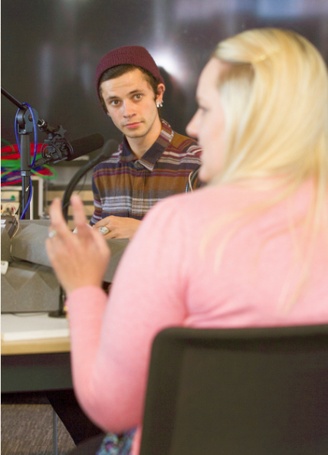
Ref: 71

Photographic images courtesy of Cambridgeshire Community Services NHS Trust ©

#4 Trackable Links

Measurable links to specific “Health Uncovered” episodes for pasting into your bespoke communications materials.

 | iTunes | Non-iTunes
Health Uncovered - Series 1 | http://bit.ly/HealthUncS1 | http://bit.ly/HealthUnS1
#1 – Sexual health, STIs | http://bit.ly/HealthUncS1E1 | http://bit.ly/HealthUnS1E1
#2 – Bullying, how it feels | http://bit.ly/HealthUncS1EZ | http://bit.ly/HealthUnS1E2
#3 – Mental health, me and my emotions | http://bit.ly/HealthUncS1E3 | http://bit.ly/HealthUnS1EE
#4 – Sexual health, are you ready? | http://bit.ly/HealthUncS1E4 | http://bit.ly/HealthUnS1E4
#5 – Mental health, are you OK? | http://bit.ly/HealthUncS1E5 | http://bit.ly/HealthUnS1E5
#6 – Grooming, could it happen to me? | http://bit.ly/HealthUncS1E6 | http://bit.ly/HealthUnS1E6

#7 – Mental health, taking control | http://bit.ly/HealthUncS1E7 | http://bit.ly/HealthUnS1E7
#8 – Mental health, asking for help | http://bit.ly/HealthUncS1E8 | http://bit.ly/HealthUnS1E8

#9 – Social media, is this real life? | http://bit.ly/HealthUncS1E9 | http://bit.ly/HealthUnS1E9
#10 – Substance misuse, know your choices | http://bit.ly/HealthUncS1E10 | http://bit.ly/HealthUnS1E10

