Modern life can make it hard to be healthy, with Type 2 diabetes adding to this challenge. Making small lifestyle changes can help you reduce your risk even if Type 2 Diabetes is in your family history.
Did you know that in Gloucestershire there are about 34,000 people diagnosed with Type 2 Diabetes and about 21,000 people are known to be at risk of developing the condition. Recent statistics published by NHS England show that 26% of those that have sadly died from Coronavirus, were also living with diabetes.
WHAT’S YOUR RISK?
Find out your risk of developing Type 2 diabetes by completing the Diabetes UK Questionnaire at https://preventing-diabetes.co.uk/Know-your-risk-dtc/
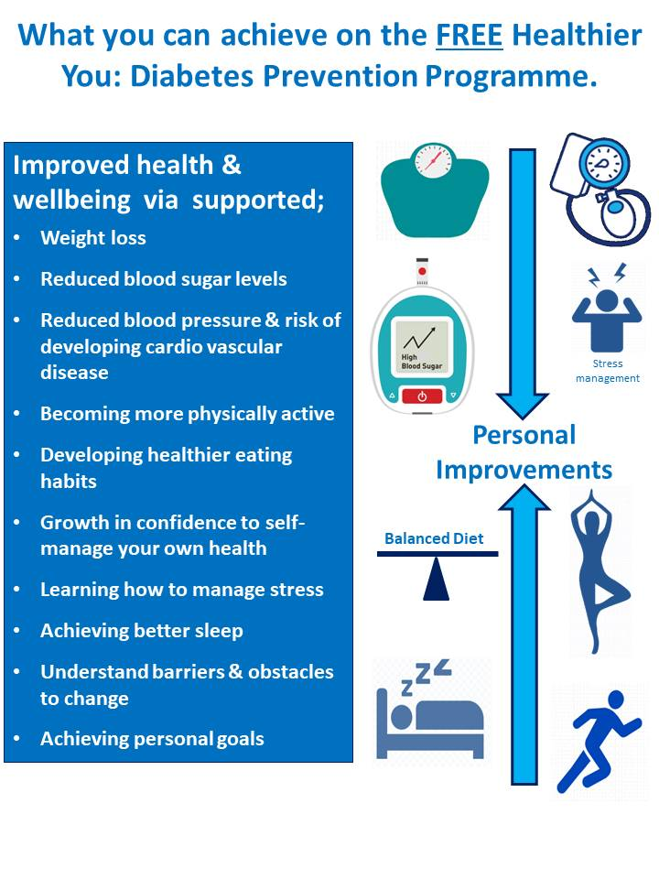
Your Free local Healthier You: NHS Diabetes Prevention Programme
Start you journey to lower your risk.
Receive support to make sustainable changes to your lifestyle now by referring yourself to your local Healthier You – Diabetes Prevention Programme.
The service is completely remote through group telephone or video calls, or you can choose the 1:1 app/computer based service with a Health Coach so there is no need to travel!
You will receive support with healthy eating and lifestyle, help with weight management and physical activity. Together this has been proven to reduce the risk of developing the disease and other long term conditions such as cardiovascular disease.
To join or find out more about your local Healthier You Provider by:
Visit the website: preventing-diabetes.co.uk
Calling: 0333 577 3010
Email: info@preventing-diabetes.co.uk

