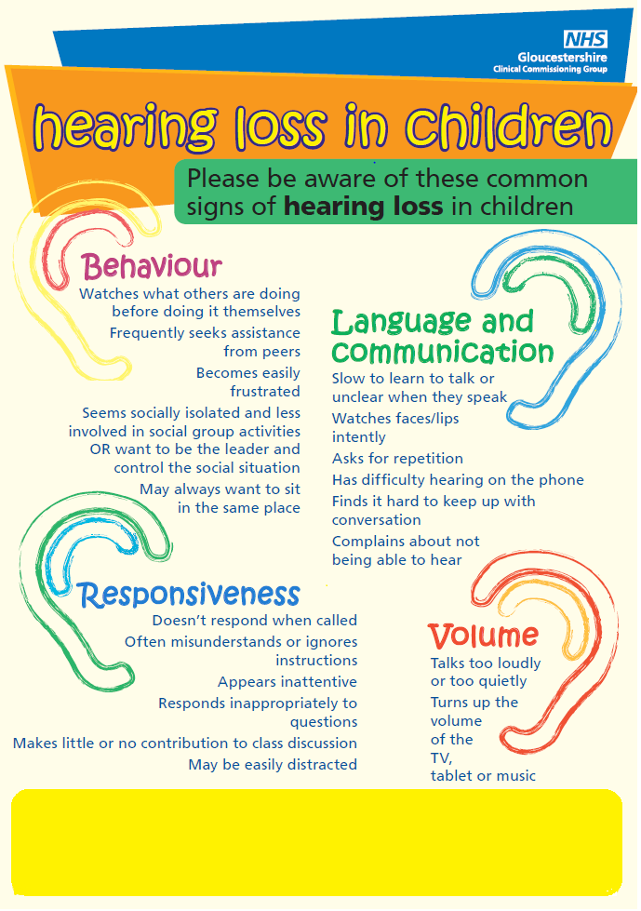

If you have any concerns about a child please discuss them with the child’s parent or carer and consider referring to paediatric audiology via a health professional. An audiology referral form is available on the professional’s resource section at (**add own website link)**. The parent/carers can take this to a health professional to complete the referral process.