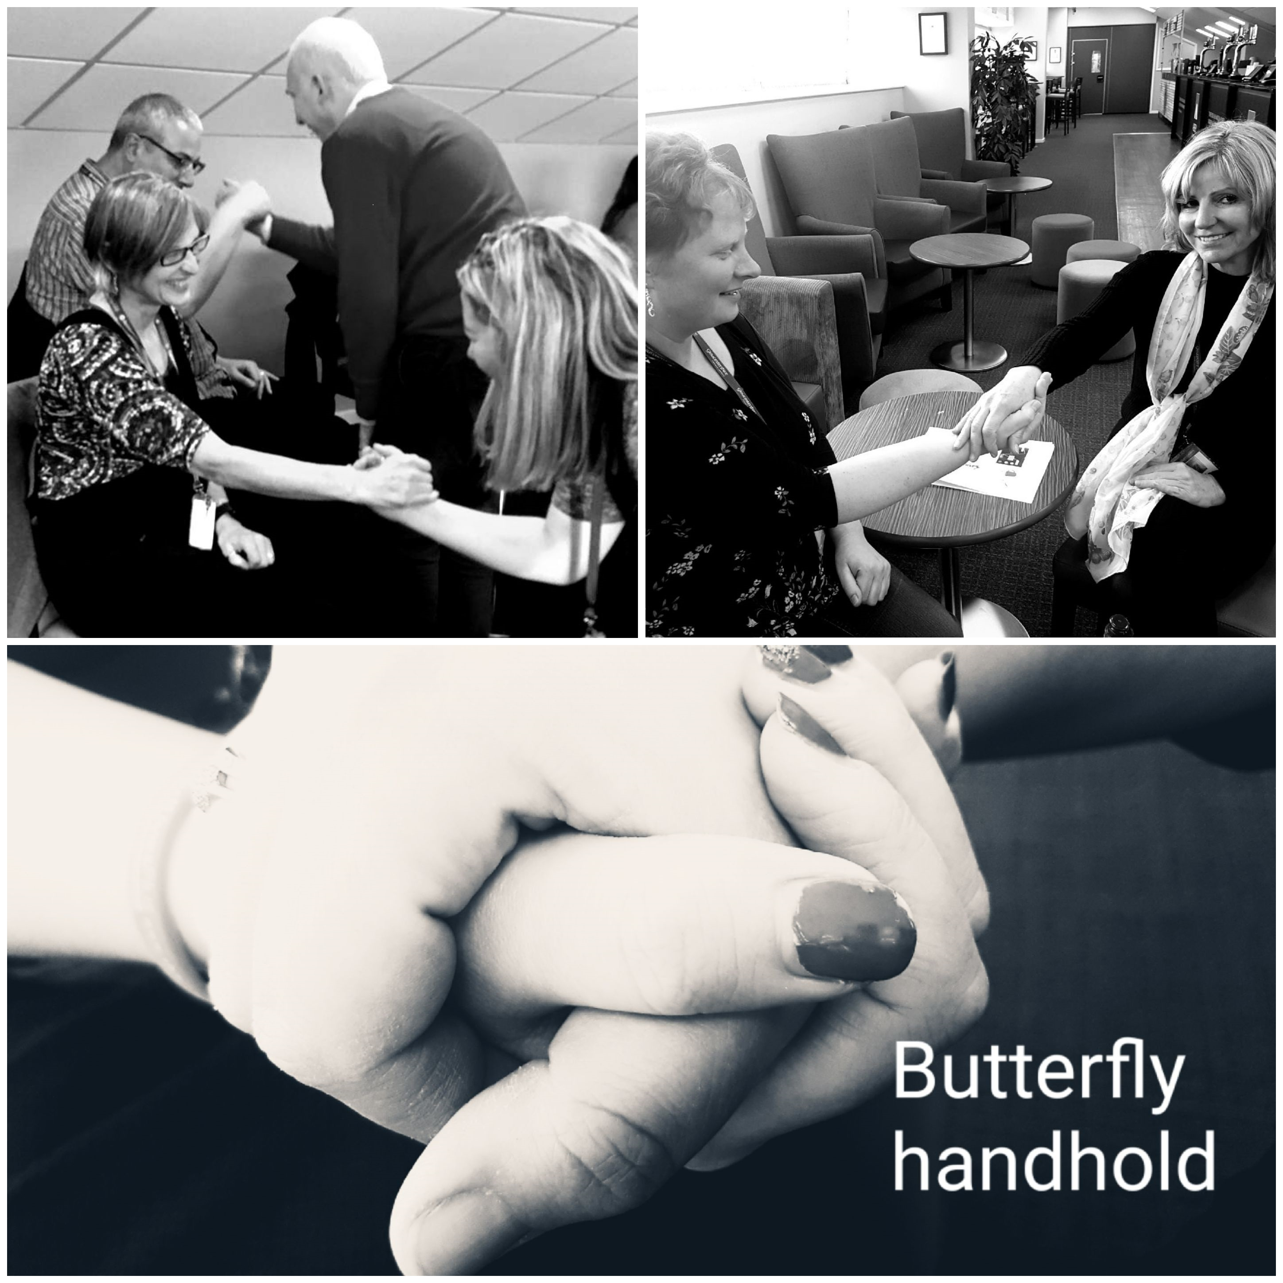

**Social Workers Event – Tuesday 6th November 2018**

Feedback received following the ‘Through the eyes of the person with dementia’ workshop delivered to Social Workers at the Gloucester Rugby Club on 6th November 2018.

“Looking and feeling the difficulties people have”

“Great knowledge and delivered in the right way”

“Actually being able to draw parallels with someone with dementia with sensory impairments.”

**EVOKE Reminiscence Sessions**

The Heritage Lottery Fund (HLF) has funded Gloucestershire Archives to run the *EVOKE* reminiscence project for two years until January 2020. Nostalgia and technology come together in the project, which uses iPads to spark memories and stories at friendly get-togethers running across the county. Designed to be fun, robust and easy to use - even for people unsure about new technologies – the *EVOKE* sessions use the award-winning *House of Memories* app developed by Liverpool Museums.

The team at Gloucestershire Archives uploaded photographs and films from their collections, carefully chosen to ‘ring a bell’ and provide local colour from every part of Gloucestershire. Many people still remember aspects of local life shown in the ‘photos, from the catastrophic floods in the 40s’ to the ploughing contests of the ‘60s’, and are happy to share their stories and memories over a cup of tea in an informal, friendly group chat. The sessions are **free of charge** and are **designed with people living with dementia and their families and friends in mind**, but can be enjoyed by anyone who fancies a trip down Memory Lane. Conversations take flight and land in unexpected places: the perils of getting your friend to draw an eyeliner ‘stocking seam’ down the back of your leg, or the downside of being the baby of the family when it came to being the last in line for the bathwater.

Please contact Kate O’Keefe: katherine.o’keefe@gloucestershire.gov.uk if you would like to book a session or just to find out more.

You can also download the *House of Memories* app **for free** to your own tablet computer or smartphone: <https://houseofmemories.co.uk/things-to-do/my-house-of-memories-app/>

It works particularly well as a way to help younger members of the family connect with older relatives.

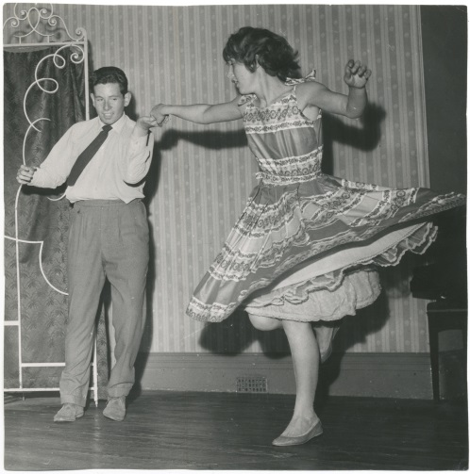

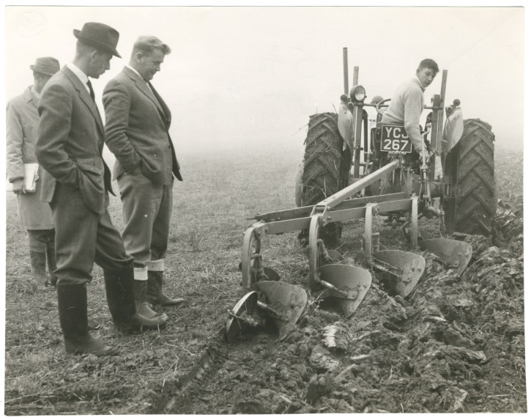

**Community Update**

A group of local Bourton on the Water residents are looking to create the town into a dementia friendly community. Greystones Farm (part of the Gloucestershire Wildlife Trust) in the town have offered the site as a possible memory café and gentle walk environment. If this is something that you would like to be involved in please contact Rachel:- [rachel.peak@nhs.net](mailto:rachel.peak@nhs.net)

Dementia Friendly Songs of Praise service happening next Wednesday 12th December at 2pm - 2.45pm at St Mary de Lode Church. It is a gentle, accessible, recognisable church service with a warm welcome and lots of familiar hymns (Carols!) followed by a chance to chat or just be with others over tea/coffee.  There is a small forecourt carpark and there will be volunteers outside to meet people before the service and just inside the door once it starts.

**Please note this newsletter is**

**TWO pages**

**This is Two of Two.**

On behalf of the Dementia Education Team we wish you all a very Happy Christmas and a Happy New Year.

C:\Program Files (x86)\Microsoft Office\MEDIA\CAGCAT10\j0183290.wmf