LEARN EQUALITY – LIVE EQUAL
A positive approach to teaching Anti-Bullying
Updated - October 2019

Session | Reception | Year 1/2 | Year 3/4 | Year 5/6
1.  What is bullying? | Show children pictures of scenarios involving:  -someone being hurt physically  -someone being teased  -someone being left out  (See Resources)  Ask children to think of a time that these events might happen on purpose and when they might be an accident. Emphasise the difference.  Circle time about how these children might feel and how you might help them to feel better. How can you be kind and be a good friend? | Y1: Show children pictures and read descriptions of scenarios involving:  -someone being hurt physically on purpose  -someone being hurt physically by accident  -someone being teased  -someone’s feelings being unintentionally hurt  -someone being left out on purpose  -someone being accidently left out  (See Resources)  Ask children to work in pairs or small groups to discuss what they think ‘Bullying’ means using these scenarios to help them. Emphasise the difference between on purpose and accidentally. Use the ideas to devise a class definition.  Y2: Show children pictures and read descriptions of scenarios involving:  -someone being hurt physically on purpose  -someone being hurt physically by accident  -someone being teased  -someone’s feelings being unintentionally hurt  -someone being left out on purpose  -someone being unintentionally left out  (See Resources)  Ask children to work in pairs or small groups to discuss what they think ‘Bullying’ means using these scenarios to help them. Emphasise the difference between on purpose and accidentally. Use the ideas to devise a class definition.  Pairs role-play the bullying scenarios and practise possible responses from the victim e.g. walking away, finding someone else to play with and most importantly, TELLING someone who can help. | Y3: Show children pictures and read descriptions of scenarios involving:  -someone being hurt physically on purpose  -someone being hurt physically by accident  -someone being teased  -someone’s feelings being  unintentionally hurt  -someone being left out on purpose  -someone being accidently left out  -someone being mean online  -someone having an online conversation  -someone being teased based on their gender  (See Resources)  Ask children to work in pairs or small groups to discuss what they think ‘Bullying’ means using these scenarios to help them. Emphasise the difference between intentional and unintentional actions. Use the ideas to devise a class definition.  Pairs role-play the bullying scenarios and include other children watching the bullying happening (bystanders). Practise possible responses from the victim e.g. walking away, finding someone else to play with and most importantly, TELLING someone who can help. Also practise responses from bystanders.  Y4: Pairs or groups brainstorm examples of bullying. (Make sure all different types of bullying are covered). Share as a class and use as a basis for a class definition of bullying.  Pairs role play scenarios from some of the examples given of different types of bullying. Practise possible responses and consider whether these might be the same or different depending on the type of bullying. | Y5: Ask children how widespread they think bullying is. How much does it happen and how much is it a problem in your school?  Pairs or small groups come up with examples of situations which may indicate different forms of bullying. (Include physical, verbal, isolation/exclusion and cyber bullying)  Children work in pairs and small groups to come up with a definition of bullying.  Y6: Ask children how widespread they think bullying is. How much does it happen and how much is it a problem in your school?  Pairs or small groups come up with examples of situations which may indicate different forms of bullying. (Include physical, verbal, isolation/exclusion and cyber bullying)  Children work in pairs and small groups to come up with a definition of bullying.  If possible look at on-line pupil survey results related to bullying for your school. Ask pupils what this information tells them about their school.  Show children poster/power point with information from the on-line pupil survey:  -Three quarters of primary pupils have not been seriously bullied over the last year  -Three quarters of those primary pupils who say they have been bullied, say their school deals well with bullying.  Discuss meanings of these findings and positive message it gives.
2.  How are we similar and how are we different? | Show YouTube video of Sesame Street http://www.youtube.com/watch?v=fgfmcAYuAj8&feature=player_embedded#at=21  Pairs of children take turns to stand up and discuss things that are the same and things that are different about them e.g. eye colour, height etc.  As a class, list things which are the same and things which are different about themselves:  “We are the same because……”  “We are different because…….”  Emphasise that we’re all different but that we all have things in common.  Choose a friend to draw and label things about them that are like you and things that are different. | Y1: Show YouTube video of Sesame Street http://www.youtube.com/watch?v=fgfmcAYuAj8&feature=player_embedded#at=21  Pairs ask questions to find out things that are the same and things that are different about each other e.g. how they look, what they like doing, their families, pets or where they were born etc. Complete a table, using pictures and captions, with ‘things that are the same’ and ‘things that are different’ about them and their friend.  (See Resources)  Discuss why both similarities and differences are important.  Y2: Recap work on similarities and differences from Year 1.  Read the story ‘Something Else’ by Kathryn Cave. After reading, ask the children to think about how the two creatures in the book are different from each other and how this makes them feel e.g. How did the blue creature feel when the other animals said he wasn’t like them? What could the other creatures have done to help the blue creature feel happier? Even very different people can find things in common.  Can they now find similarities between the two creatures? | Y3: In Circle Time, ‘The Sun shines on everyone who..’ game. (Take one chair from the circle so one person is always left without a chair. This person stands in the middle of the circle and says ‘The sun shines on everyone who e.g. likes pizza or has two brothers.’ All the children who this applies to, change places.)  Circle Time: Complete sentence stem, ‘I am the same as my friend because …’ and ‘I am different to my friend because …’  Discuss idea that different people live in different ways.  Pairs or small groups make a list of questions to be given to other children to find out similarities and differences e.g. What do you like to eat and drink? What do you like to wear? What hair colour do you have? Where do you live? Where do you go on holiday? Groups join up and ask each other the questions. Class discussion on the importance of accepting and respecting the similarities and differences between people.  Y4: In Circle Time, ‘The Sun shines on everyone who’… game. (Take one chair from the circle so one person is always left without a chair. This person stands in the middle of the circle and says ‘The sun shines on everyone who e.g. likes pizza or has two brothers.’ All the children who this applies to, change places.)  Pairs or small groups list all the differences there might be in their school. Highlight in one colour all the differences you could spot from the outside (e.g. race, gender, age, size) and highlight in another colour, the differences you could only find out from talking to somebody (e.g. religion, likes/dislikes, lifestyle). Make a class list of the two categories. Emphasise the positive nature of differences.  In Circle Time, complete the sentence stem, ‘If we were all the same there would be no…’ | Y5: In Circle Time, complete the sentence stem, ‘I am unique because…’ Encourage children to include sentences such as, ‘because I am the only person in the class with red curly hair‘ etc.  Children make a table with 3 columns which includes a list of things they like e.g. hobbies, favourite foods, favourite bands, pets etc. The next column will be to list children who also like these things and the third column for those who don’t. (See Resources)  Pupils go around the class and find out. Class discussion: What have we learnt about each other? Are we all different? All the same? Does this matter? Is it important?  Lead into a discussion about the importance of treating people equally.  Design a poster promoting equality in the classroom/school.  Y6: Recap work on Equality from Year 5. Ask children how they think pupils are treated in their school. Are they treated equally? Are there aspects of school life where you feel pupils are not treated equally?  Show children a copy of the school’s Equality Policy.  Small groups work together to produce a pupil friendly version of an Equality Policy for their school to go on their website.
3.  How are our families the same and how are they different? | If you do not have access to Stonewall’s different families, same love, resource pack, you can visit this page and download a resource that will give you the range images you need to be able to run the discussion based starters suggested here - https://www.stonewall.org.uk/resources/different-families-same-love-pack  Stonewall:  Using your own set of resources, or the visual you’ve downloaded from the website - Talk about children’s different families and discuss ‘different families, same love’ poster  Talk about who is in your family. Draw and label pictures of own family. | Y1: Stonewall:  Using your own set of resources, or the visual you’ve downloaded from the website - Discuss children’s different families and discuss the idea behind ‘different families, same love’  Discuss things that their families do to help them be happy and work well e.g. activities they do together, how they help each other etc. Draw and write about some of these things.  Y2: Stonewall:  Using your own set of resources, or the visual you’ve downloaded from the website - Discuss children’s different families and discuss ‘different families, same love’ poster  Discuss what makes a family work well together and what all families need. Make posters about this. | Y3: Stonewall:  Using your own set of resources, or the visual you’ve downloaded from the website - Discuss children’s different families and discuss ‘different families, same love’ poster  Draw and label people who are in your family. Include extended and step families. Write captions about what is special about these different people and things you do together etc.  Y4: Stonewall:  Using your own set of resources, or the visual you’ve downloaded from the website - Discuss children’s different families and discuss ‘different families, same love’ poster  Look at and model different family trees, including at least one which includes a same-sex parent. Draw your own family tree. (Up to three generations) | Y5: Stonewall:  Using your own set of resources, or the visual you’ve downloaded from the website - Discuss children’s different families and discuss ‘different families, same love’ poster  Develop work on family trees from Year 4. Draw more extended family trees and compare them with each other’s. Discuss how they are all different but that they are all families.  Y6: Stonewall:  Using your own set of resources, or the visual you’ve downloaded from the website - Discuss children’s different families and discuss ‘different families, same love’ poster  Show clips of different families from various TV shows. How are they the same and different from their families and what sort of families are missing from TV and why? (Idea that media often portrays only two-parent opposite sex families)
4.  How are we similar and how are we different?  Gender stereotypes | http://lettoysbetoys.org.uk have a wide range of additional teaching resources and a ’10 ways to challenge gender stereotyping in your classroom’ document that shares a range of practical ideas to tackle a gender stereotyping.
 | Children list and show different games and toys they like to play with. Ask if you can sort them into girls and boys toys and games. Try to do this. Is this right? Talk about how boys and girls can play with any of the toys and games and discuss ways you could help this to happen in your classroom. | Y1: Ask children to list toys and games that are for boys and toys and games that are for girls. Have two columns on the flip chart with these lists. Ask children How did you decide which list to put them in? Was it easy to do or did some children disagree? Do you think it is right to say some games and toys are only for girls or boys? Emphasise that the games and toys can be played by either girls or boys. Draw and write about some games and toys you like playing with.  Y2: Show picture of a boy and a girl. Match given statements to the boy or girl regarding their likes and hobbies e.g. pink is my favourite colour, I like playing football etc. Ask whether this was a hard thing to do. Discuss and challenge any stereotyping. Pairs discuss any examples of gender stereotyping that go on in school e.g. playtime games and suggest strategies to overcome them. | Y3: Show picture of a boy and a girl. Match given statements to the boy or girl. Include some more controversial and thought provoking statements e.g. I am good at maths; I like writing stories; I want to be a Nurse when I grow up; I want to stay at home and bring up my family when I grow up etc. Ask whether this was a hard thing to do. Discuss and challenge any stereotyping. Pairs discuss any examples of gender stereotyping that go on in school e.g. playtime games and suggest strategies to overcome them.  Y4: Write a unisex name at top of a sheet (e.g. Sam). Write down imaginary details about this person: favourite sport, favourite colour, favourite game etc. When completed, ask children what sex their person was. Discuss in pairs how this has affected the choice of description you have given. Challenge any stereotyping. Groups discuss any e.gs of gender stereotyping that may go on in school or at home and suggest ways you might change this. | Y5: Gender stereotypes in the media. Look at examples. Discuss and complete table with examples of images often portrayed in the media (eg woman making dinner) and possible alternatives to such images.  Make poster from cut up images from internet with ‘stereotyped images’ and ‘non-stereotypes images’.  Y6: Children to research jobs traditionally viewed as male or female and explore how these occupations have changed over time e.g. Nursing, Engineering and job change in WW2.
5.  How can we stay safe on the internet and our phones? | www.thinkuknow.co.uk  Click on relevant age to access resources for 4-7 year olds (Here you can access Jessie and Friends video clips with accompanying printable story/activity books linked to accessing videos via the web and sharing photos/pictures via the web)  Register on teacher’s section to access additional resources. | Y1/2: www.thinkuknow.co.uk  Click on relevant age to access resources for 4-7 year olds (Here you can access more Jessie and Friends video clips with accompanying printable story/activity books linked to online gaming)  Register on teacher’s section to access additional resources. | Y3: www.thinkuknow.co.uk  Click on relevant age to access resources for 8-10year olds (Here you can access online games/videos linked to staying safe while surfing the net)  You may need access to an IT suite if your school does not have access to in class tablets.  Register on teacher’s section to access additional resources.  Pairs or small groups discuss what is meant by ‘Cyberbullying’ and give examples.  Y4: Pairs or small groups are given scenarios such as the following:  -you’ve started getting nasty texts, what do you do?  -you’ve received some inappropriate emails, what do you do?  -somebody has sent you a nasty email, what do you do?  -your friend wants you to join in an instant chat conversation which is being nasty about another child, what do you do?  -you receive a chain message on your mobile, what do you do?  Children consider the online dangers of these scenarios and possible consequences. Role-play possible resolutions and present to rest of the class. | Y5: www.thinkuknow.co.uk  Click on relevant age to access resources for 8-10year olds (Here your children can access 3 x video clips about the pressure social media can have on you as a user within a group and an interactive game that links to all 3)  Register on teacher’s section to access additional resources.  Pairs or small groups discuss what is meant by ‘Cyberbullying’ and give examples.  Y6: Pairs or small groups are given scenarios such as the following:  -you’ve become the victim of prank calling or silent calling on your mobile, what do you do?  -you’ve posted personal details such as your mobile number or home address and someone you don’t know tries to contact you, what do you do?  -someone you’ve met online asks to meet you, what do you do?  -someone has posted nasty messages and/or photos of you on Facebook, what do you do?  -other children are ganging up on you and being nasty to you on a gaming site, what do you do?  Children consider the online dangers of these scenarios and possible consequences. Role-play possible resolutions and present to rest of the class.
6.  How can we stay safe on the internet and our phones? | N/A | N/A | Y4: Read ‘Tara’s Story’ (See Resources)  Discuss the dangers of giving out personal information over the internet.  Why was Tara fooled?  What should she have done differently?  Make a story board of Tara’s story. | Y5: Children close their eyes while an unknown adult goes behind a screen with access to a computer linked to the IWB.  Tell the children that we want to get to know more about who is behind the screen so we will ask them questions and they will type their responses to appear on the IWB.  Children take it in turns to ask questions and the person behind the screen answers as if they are a ten year old girl. At the end, ask the children to describe the picture we have built up of the person behind the screen and what we think they are like. The person behind the screen is then revealed. Discuss the fact that online we may think we are talking to a child like us but it could in fact be anyone. Ask questions about why this could be dangerous and highlight the importance of not giving out personal information.  Watch and discuss CEOP video https://www.youtube.com/watch?v=Zyux6NGxRYk  Make a poster about staying safe on the internet.  Y6: Discuss definitions of ‘Cyber bullying’  View film ‘Let’s fight it together’ at http://www.digizen.org  Discuss the film and the roles the different children played e.g. Was Kim the only person who was doing the bullying? What could Joe have done differently?  Click on the Character Interviews for further discussion.

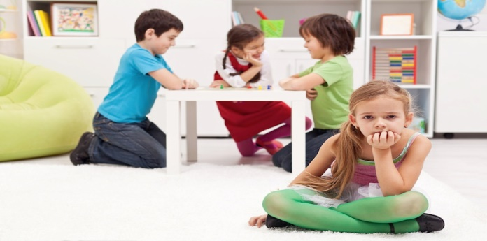
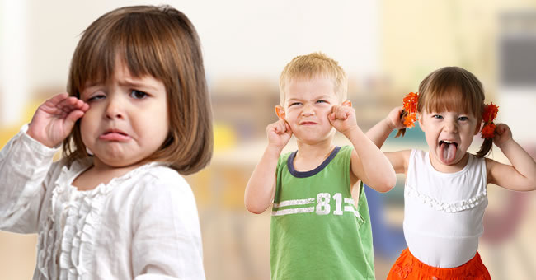
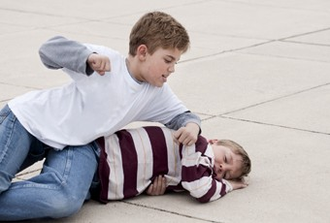
Reception Session 1 Resource

Year 1/2 Session 1 Resource

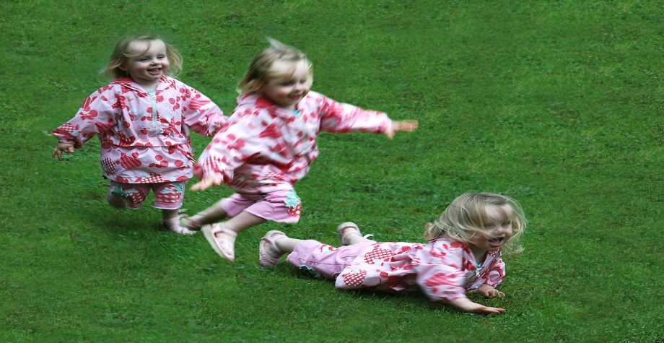

Year 3 Session 1 Resource

Ben is punching Dan because he says he’s a wimp and that nobody likes him.
Becca falls over and then Sally trips over her and hurts herself.

Amy is crying because Tim and Sasha are pulling faces at her and teasing her.

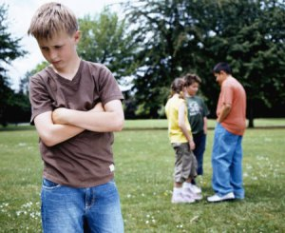
Jamie is feeling sad and lonely because his friends are busy talking about something else. They haven’s spotted Jamie by himself.

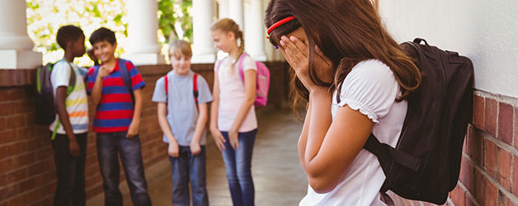
Lola is upset because her friends are leaving her out. They are planning a game to play without her and they know Lola is upset.

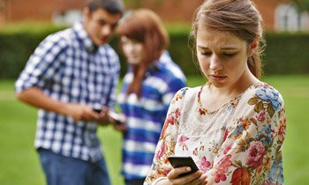
Kate is feeling upset because someone has sent her a nasty text message on her phone. It has happened before but she doesn’t know who has been sending them.

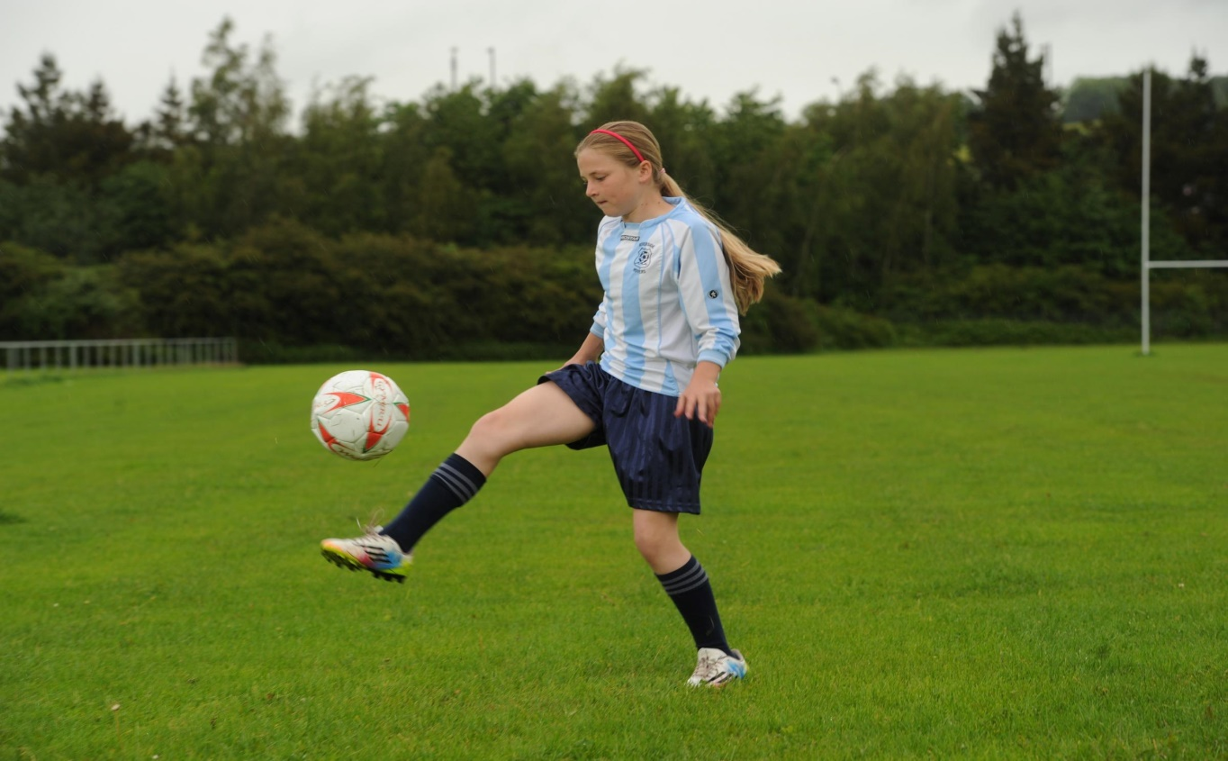
Jasmine loves playing football but she is feeling upset because the other girls in her class have been teasing her and telling her that football is for boys. Now the boys have been joining in too and saying she can’t play in their team because she’s a girl.
Year 1 Session 2 Resource

How am I the same as my friend? | How am I different to my friend?
Year 5 Session 2 Resource

Things I like | Other children who like these things | Children who don’t like these things
Year 5 Session 4 Resource

Stereotyped Image | Alternative Image

Year 4 Session 6 Resource

Tara’s Story

Tara Peterson grabbed her backpack from the bench,waved to the other members of the football team and rushed off home. She was in a hurry, because she wantedto catch Jamie21 in the chat room before he had to get off-line for dinner. She turned the key in the lock and rushed through the door, yelling, “Mum! I’m home!" She took the stairs two at a time – there were only five minutes left before Jamie21 would be going off line.
She rushed to the computer and signed on as “FootieGirl”– and there he was! Right where he always was, in her favourite teen chat room, Teen Sports.

FootieGirl: Hi Jamie21. Guess what? We won!
Jamie21: Hi FootieGirl. What was the score?
FootieGirl: 2 goals to 0! I scored the first goal! We even had our photo taken by the local paper. I’m going to be famous!!
Jamie21: Cool. Who do you play next week?
FootieGirl: Green Lane School. They were the champs last year. It’ll be a tough game.
Jamie21: Are you still wearing the No.9 shirt?
FootieGirl: No, I’m No.8 now.
Jamie21: What happened to the last No. 8?
FootieGirl: She moved to another school. The coach said that No.8 girls have to be blonde, so he chose me! ;-)
Jamie21: Great! I gotta go. Mum’s calling me for dinner. See you tomorrow.
FootieGirl: CU L8R

Tara chatted with a few other friends for a while and then logged off. Jamie21 was her favourite on-line friend. He was fourteen, like Tara, but he lived in Birmingham. He played football too and said he thought they should have mixed football matches so they could play each other. Although she didn’t even know his real name, and he didn’t know hers, she knew lots about him. He was much more fun than most of the other kids in the chat room. He knew everything about football and they liked the same pop groups. She wished she lived closer to Birmingham,so they could go to football matches together.Jamie21 really cared about her – he was always warning hernot to tell anyone her real name or address. It was nice that he cared, but Tara already knew not to share any personal information. Her parents and her teachers had all discussed this with her and the other kids. She was very careful never to give out anything that could help anyone find her in real life. Just then her mother called her, and she ran down the stairs to dinner to share the good news with her family about the match.

The following week, Tara had a team practice every day. Somehow things didn’t feel right, though. It was as though someone was following her. She kept looking over her shoulder when she walked home, and it was starting to get dark earlier. She found herself picking up her pace, and was winded when she arrived home. She unlocked the door quickly and looked around. Although she didn’t see anyone, she was very uncomfortable. As she got into her house on Wednesday, she remembered that her Mum would be working late today. She wished her Mum had been there, as it would have been good just to say “Hello”.

FootieGirl: Hi Jamie21 . . .
Jamie21: Hi FootieGirl, what’s up?
FootieGirl: I was nervous today. Must be worrying about the next game. Thought someone was watching me on the way home.
Jamie21: Spooky! Did you see anyone following you?
FootieGirl: No, but it felt weird. Like I could feel someone watching me . . . but no one was there every time I looked.
Jamie21: Are your parents home?
FootieGirl: Yes. It’s okay. Probably just pre-match nerves. ;-)
Jamie21: You haven’t told anyone on line where you live or your real name or anything, have you?
FootieGirl: No, stop lecturing me! You sound like my parents! ;->
Jamie21: Oh! Oh! Gotta stop that!
FootieGirl: LOL [laughing out loud]
Jamie21: ROFLOL . . . [rolling on the floor laughing out loud]

Tara forgot her fear and chatted until her Mum came home and dinner was ready.

The next day was the big game. Tara played really well, and although she didn’t score a goal, the team won, going on to the finals. When she got home that night, she logged on and told Jamie21 about their big win, and complained that they had practice the next day after school, so she might not be able to chat to him.

At the next day’s practice, she looked around the school field and saw a man standing there looking right at her. He looked okay, but she felt uncomfortable because he was only looking at her, not the other girls. Every time she glanced in his direction, he was still watching, but once the practice got going, she needed to concentrate. It was when she was walking home that she remembered him. This time, she was sure someone was following her. She kept looking around, and although she didn’t see anyone, she was really scared. She took the long way home, because it was busier and better lit, but wished she were already safe and sound in her home. Once, when she looked in a shop window, she saw a reflection of someone she thought might be the man at school, but when she turned around no one was there. At one point she even heard footsteps.

As she neared her house, she broke into a run. It sounded like the footsteps were speeding up, too, and she ran even faster. She unlocked the door and slammed it shut. Her mother, alarmed at the noise, walked into the living room from the kitchen. “Are you okay, Tara?” she asked. “You look upset.” Tara caught her breath, and said that she was just in a rush to get home.

When she took the stairs this time, she took them slowly, thinking while she climbed. She really had to talk to
Jamie21. She was very scared. But when she logged on, Jamie21 wasn’t in the chat room. She sent him an instant message, and saw that he wasn’t even on line. Just when she really needed him! Then the doorbell rang. She heard her mother answer it and heard a male voice. A few minutes later, her mother called her down. She was still trying to figure out how to tell her parents about her fear without alarming them.

When she climbed down the stairs, her thoughts were elsewhere. Her mother was sitting in the living room with a man – the one she had seen on the football field! She started to worry. Her mother said, “Tara, please sit down. This is Sergeant Thompson from the police.”

"Hi, FootieGirl," said the man. “I’m Jamie21.”

She couldn’t believe her ears. Jamie21? This policeman? But Jamie21 was only fourteen, and he lived in Birmingham!

“Let me explain,” he said, and proceeded to tell her that he worked undercover in chat rooms trying to protect children from adults on line.
“But how did you find me?” Tara asked. “I never gave you my real name or any real information.”
“No, you never gave me your name, but you gave me lots of other information about you. You gave me the name of the team you were playing football against this week. It was simple enough for me to find out where Green Lane School is. I called them and asked which team they were playing this week. Then I looked in the local paper and found your photo with the team, with all the names on it. Then I looked up all the Petersons in the telephone directory, and found your address and telephone number. I called your parents and told them I was concerned.”

Tara was stunned. How could this policeman sitting in front of her be her friend Jamie21? Besides, the police officer said he was from her local town. How could that be when Jamie21 was from Birmingham? She knew who Jamie21 was because he told her things about himself. And she didn’t take his word for it, she checked him out. He told her she could see his photo on his school web site, where he was in the football team for Year 9. She’d looked at the web site, and there he was – he looked really fit, too. That was written proof! But Tara started paying attention when Sergeant Thompson explained how he had made it up just to help convince her of his false identity. He then explained that he had followed her home, after spotting her on the field, as the blonde girl wearing the number 8 shirt.

“I did this to help you,” he said. “Even when you think you’re being careful, you can give away information that an adult could use to find out who you are, and where you live.”
“But you sounded like a 14-year-old!” said Tara. “And you said you liked Manchester United and your favourite pop group was the same as mine.”
“Yes, I did, and it was quite easy to pretend to be the same age as you. I want you to promise me two things. First, that you will be very, very careful from now on about what you disclose to other people in a chat room. The second thing is that I have to give a talk to another school next week, about keeping safe on line. Will you come and help me give the talk?”

Tara agreed, of course. She still uses chat-rooms and has made lots of friends that way – but every time she’s asked something personal, she thinks hard before she answers. She also knows that you can’t always believe what other people say.

