
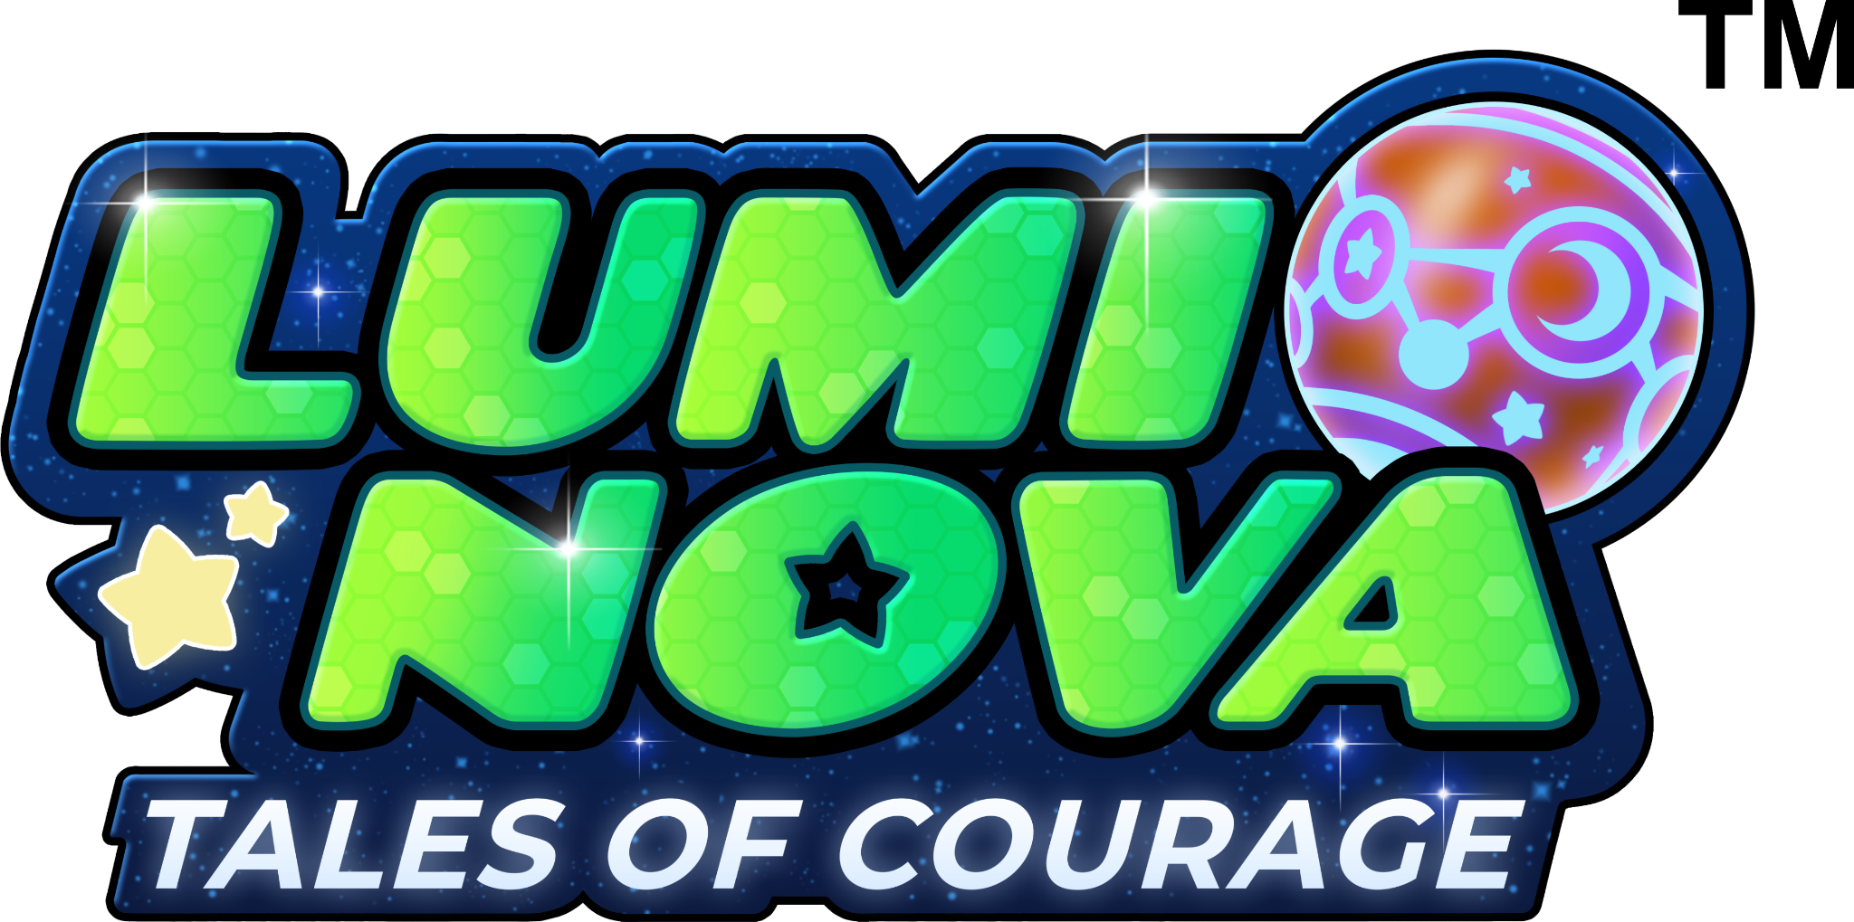

Dear Parent/Carer,
With the end of the year imminent, we wanted to remind you to take advantage of Lumi Nova over the winter holidays. For some children, winter can be a tricky time. New year transitions, busy shopping days, or festive gatherings can all bring about a bit of worry.
What is Lumi Nova?
- For children aged 7-12 years old with difficulties with worries / anxiety
- Lumi Nova is based on Cognitive Behavioural Therapy (CBT)
- Recommended by the National Institute for Health and Care Excellence (NICE)
- Is free for families in Gloucestershire in partnership with NHS Gloucestershire ICB
Lumi Nova can help your child to face their worries by breaking them down into small manageable challenges and can support your child with:
- Returning to school or starting a new school
- Making new friends and going to social events
- Speaking in front of a group
- And lots more!
Get access to use Lumi Nova over the winter months by registering for a game key to access the app here: luminova.app/gloucestershire or scan the QR code below:
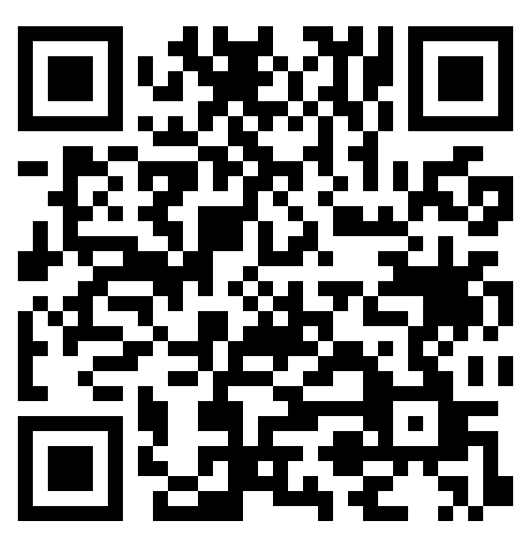
For help using the app you can also email the Lumi Nova team at luminova@bfb-labs.com.
Yours Sincerely,
[Insert name of school contact]
* Please note, Lumi Nova is not recommended for use with children who have severe anxiety, are in crisis, have suicidal thoughts or are at risk of self harming without clinical supervision. It is also not suitable for children with more complex needs or disabilities preventing them from using a mobile device. Where Lumi Nova is used to support neurodivergent children or those with SEND with worries, it is recommended to use the game alongside professional support, and that necessary adjustments are made prior to use to meet their sensory needs first.

