OPERATION ENCOMPASS
FREQUENTLY ASKED QUESTIONS

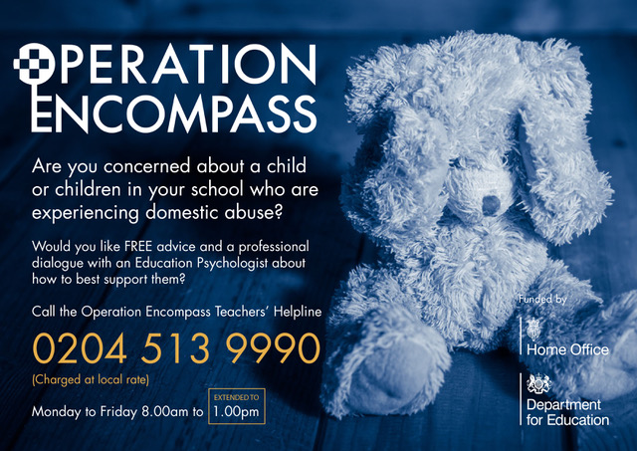

Does the notification have to come through Egress?
Yes, this is the encrypted mechanism used by the Local Authority

Is it obvious that the email is Operation Encompass?
Yes. Currently virtually all Operation Encompass notifications will be sent from masheducation@gloucestershire.gov.uk and the subject title will be Operation Encompass, School/nursery name, date, e.g. “Operation Encompass 4.1.21 ABC School”

What is the best contact number for Halah Shams-El Din – Senior Education Researcher in the MASH?

Halah Shams El-Din halah.shamsel-din@gloucestershire.gov.uk Senior MASH Education researcher 01452 328953
Claire Purves claire.purves@gloucestershire.gov.uk (2.5 days a week) MASH Education researcher 01452 328272
Rehana Tola Rehana.tola@gloucestershire.gov.uk (Term time only) MASH Education researcher 01452 425681
Faith Wade faith.wade@gloucestershire.gov.uk (2.5 days a week) MASH Education researcher 01452 328951

A parent or child has told us that the police have been out to their house/spoken to them, why haven’t we had an Operation Encompass notification?
The police may have been out for different reasons, e.g. welfare concerns, disputes with neighbours, drugs, anti-social behaviour, etc. Operation Encompass is just for DA/DV related incidents.

We are aware of a DA/DV incident in a family but haven’t had an Operation Encompass notification, what do we do?
Operation Encompass notifications will only be sent out following incidents where the police have been called out, but there will be a significant number of incidents that they aren’t called out to. If a child or parent makes a disclosure please follow your safeguarding procedures and call the Police/MASH as appropriate.

Operation Encompass Notifications come from the Police via MASH Education. Are Children’s Social Care aware?
The police reports that the notification information comes from are passed over to the MASH (Social Care). If the family are already open to Social Care the police report will be shared with their Social Worker, if the family do not currently have a social worker (even if they have been open to Social Care in the past), the report will be assessed within the MASH and you may be asked to provide further information either via a Strategy Meeting or over the phone to one of the MASH Education team.

The date on the incident is a while back, why weren’t we told earlier?
The paperwork that the notification information comes from cannot always be completed with the family on the same day as the incident has taken place and the police sometimes need to return to complete it, so there is sometimes a delay between the incident taking place and the notification being sent out. Please also check that you are accessing the spreadsheet directly rather than via Egress as Egress seems to Americanise dates- e.g. an incident that took place on 6/12/20 could show as 12/6/20. If in doubt you are welcome to call MASH Education /Halah for clarification.

We have to request Egress access each time a notification is sent out, why?

This seems to be connected to the way the diverts from the encompass@ email addresses are set up in schools because not all staff need to request access each time. If you have requested Egress access via the link in the email and haven’t been granted access within half an hour please call Halah (or one of the MASH Education team covering Annual Leave).

We have other concerns about the family as well as the Operation Encompass notification, what do we do?
You can call the Community Social Workers or the MASH for advice.

The information given in the notification is very limited, what are we expected to do with it?
The incidents will still be under investigation so we cannot share more detail at this point but notification helps you build a bigger picture of what is happening for the family and may provide a context for a change in behaviour, so it is very important that you add the notification to the child’s record and make key staff aware.
DA alerts will be received following an incident relating to any family member over the age of 16. Therefore they do not always indicate an incident between parents / carers, but the incident could relate to an older sibling , another family member, or an ex-partner. This would be the case whether or not the incident happened at the home address. As a result, please ensure that there is no presumption made by staff as to who was involved in the incident , nor any presumptions made as to who the victims or perpetrators are in this incident, even if you are aware of who the victims and perpatrators were in previous incidents.
In the light of this, it is not advisable to discuss these notifications with parent / carers unless they approach you, as this could lead you to inadvertently disclosing information on an ex-partner or other family member.

What do you mean by cross referencing files?
We advise settings to cross reference files. E.g If children have an “academic” file that has general information on it and then you have safeguarding concerns. You should open up a separate file for that child to put any disclosures etc on. We suggest that you put a “red dot” (can be any colour) on the “academic file”. This then alerts staff that information is held elsewhere. It then means that when children transition to the next setting is a prompt to send all the files you have.

A child (or parent/carer) has made a disclosure following an Operation Encompass notification, what should we do?
Opportunities for the child or parents /carers to talk to staff can be extremely important and if they make a disclosure please follow your safeguarding procedures and contact the MASH if appropriate as the disclosure may be about a separate incident or provide further important details about an incident which is currently under investigation.

I have received an Operation Encompass notification for a child/family who is currently learning at home due to lockdown, what should I do?
It would be advisable to increase the frequency of contact with the family- regular contact between school and the child and family can provide really important emotional support for the family and a key opportunity for disclosures to be made.

We don’t appear to have received any Operation Encompass notifications for a long time. How often should we be expecting to receive notifications?
The frequency of notifications can be very hard to predict and will depend on a lot of different factors, including the size of your school. It is very important that you update the diverts from your encompass email address, e.g. when staff leave or start at your setting. You are welcome to call Halah/MASH Education to check when your last notification was sent out.

A new column has been added to the notifications since February 2021, what do the different levels of risk mean?
Standard Risk: Current evidence does not indicate likelihood of causing serious harm.

Medium Risk: There are identifiable indicators of risk of serious harm. The perpetrator has the potential to cause serious harm but is unlikely to do so unless there is a change in circumstances, for example, failure to take medication, loss of accommodation, relationship breakdown, and drug or alcohol misuse. - You may receive a request for further information from MASH Education or contact from the allocated Social worker.

High Risk: There are identifiable indicators of risk of serious harm. The potential event could happen at any time and the impact would be serious.

Risk of serious harm (Home Office 2002): ‘A risk which is life threatening and/or traumatic, and from which recovery, whether physical or psychological, can be expected to be difficult or impossible’
You may receive an urgent invitation to a MASH Strategy meeting or a request for further information from MASH Education or contact from the allocated Social worker.

Where can I get a template for a chronology form from?
https://www.gscb.org.uk/i-work-with-children-young-people-and-parents/safeguarding-in-education-and-early-years/

Where can I find a copy of the Professional Curiosity briefing?
https://www.gscb.org.uk/i-work-with-children-young-people-and-parents/serious-case-reviews-and-learning-from-reviews-and-audits/practice-briefings/

If we transfer files to a child’s next setting, do we still have to keep copies of them?
Advice is, if you are posting the file (signed for) then yes keep a copy of the complete file until you receive confirmation that the file has been received. Always keep a copy of the chronology on the safeguarding file.

We don’t have internet connection at our setting.
MASH Education will always ring pre-school/nursery, independent or Post- 16 settings before emailing an Operation Encompass notification to double check that the child is definitely on roll so you will be aware of the notification.

Can we get a copy of the powerpoint presentation?
https://www.gscb.org.uk/i-work-with-children-young-people-and-parents/safeguarding-in-education-and-early-years/

We missed the training, are you running more sessions?
At the moment, there are no plans to run additional training sessions, however there is a recording of a session available at https://www.gscb.org.uk/i-work-with-children-young-people-and-parents/safeguarding-in-education-and-early-years/

Will after school clubs be involved?
If they are the same site as a school, then the notification would be sent to the school. We would expect the Key Adult in the school to share the information on a need to know basis.

Where can we find more information on the Traded Service for Early Years?
www.gloucestershire.gov.uk/early-years-service

What about GDPR/Data Protection/Information Sharing Agreements ?
Information Sharing Agreements are in place between police and local authority which cover the lawful sharing of this information. The Operation Encompass process is therefore compliant with the Data Protection Act and is subject to a Specific Information Sharing Agreement sitting under the GISPA.

