PARENT_MAIL_TEMPLATE

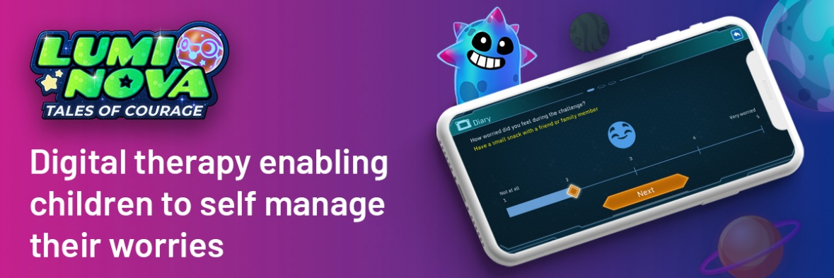

Student wellbeing is central to the ethos of our school. We are therefore delighted to share with you a NHS Gloucestershire funded service designed to support young people aged 7-12 (years 3-7) who are experiencing fears or worries; Lumi Nova.

What is Lumi Nova?
Lumi Nova: Tales of courage is an intergalactic adventure game where players step into the shoes of a newly recruited Luminaut and start an exciting adventure through space - travelling to different planets, meeting new characters, solving puzzles and attempting challenges. Lumi Nova support young people to fight fears & manage worries. Whilst exploring planets, customising characters and earning treasure your child breaks their fears and worries down into manageable steps, learning life-long skills and building resilience.

Lumi Nova is designed for 7 - 12 year olds (school years 3 - 7) who are having difficulties with fears and worries related to social situations, separation or phobias, but may also be helpful for young people outside this age range.
Designed by BFB Labs, Lumi Nova was developed with NHS clinicians and leading academics. It is based upon Cognitive Behavioural Therapy and Exposure Therapy which are proven to be effective. Lumi Nova is recommended by NICE (National Institute for Health & Care Excellence) and adheres to strict standards of clinical safety.

How to Access Lumi Nova:
To use Lumi Nova you must first register to get a game key by visiting luminova.app/glos or by scanning the QR code below, and completing a short registration form. You will then receive an SMS message that will guide you through getting started.

You will be directed to download Lumi Nova. Lumi Nova is free to download from the Apple and Google Play Stores and is compatible with iPhones, iPads and most Android smartphones and tablets.
Where can I find out more about Lumi Nova?
- More information about Lumi Nova including FAQs and case studies can be found at luminova.app/glos
- If you have any questions please reach out to the Lumi Nova team: luminova@bfb-labs.com
- To listen to a short presentation about Lumi Nova you can attend a 30 minute Parent Lumi Nova Discovery Session
Yours Sincerely
[DSL / Wellbeing Lead / Headteacher]

