R

Things that worried us about returning to school…

Things that have worried me…

Things I have enjoyed whilst on lockdown…

Things that I am looking forward to when returning to school…



**Rainbow Return**

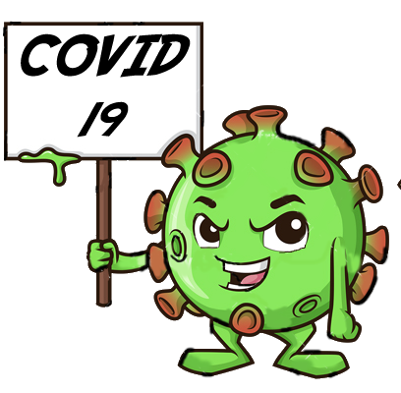

Our Covid 19 journey as a family…