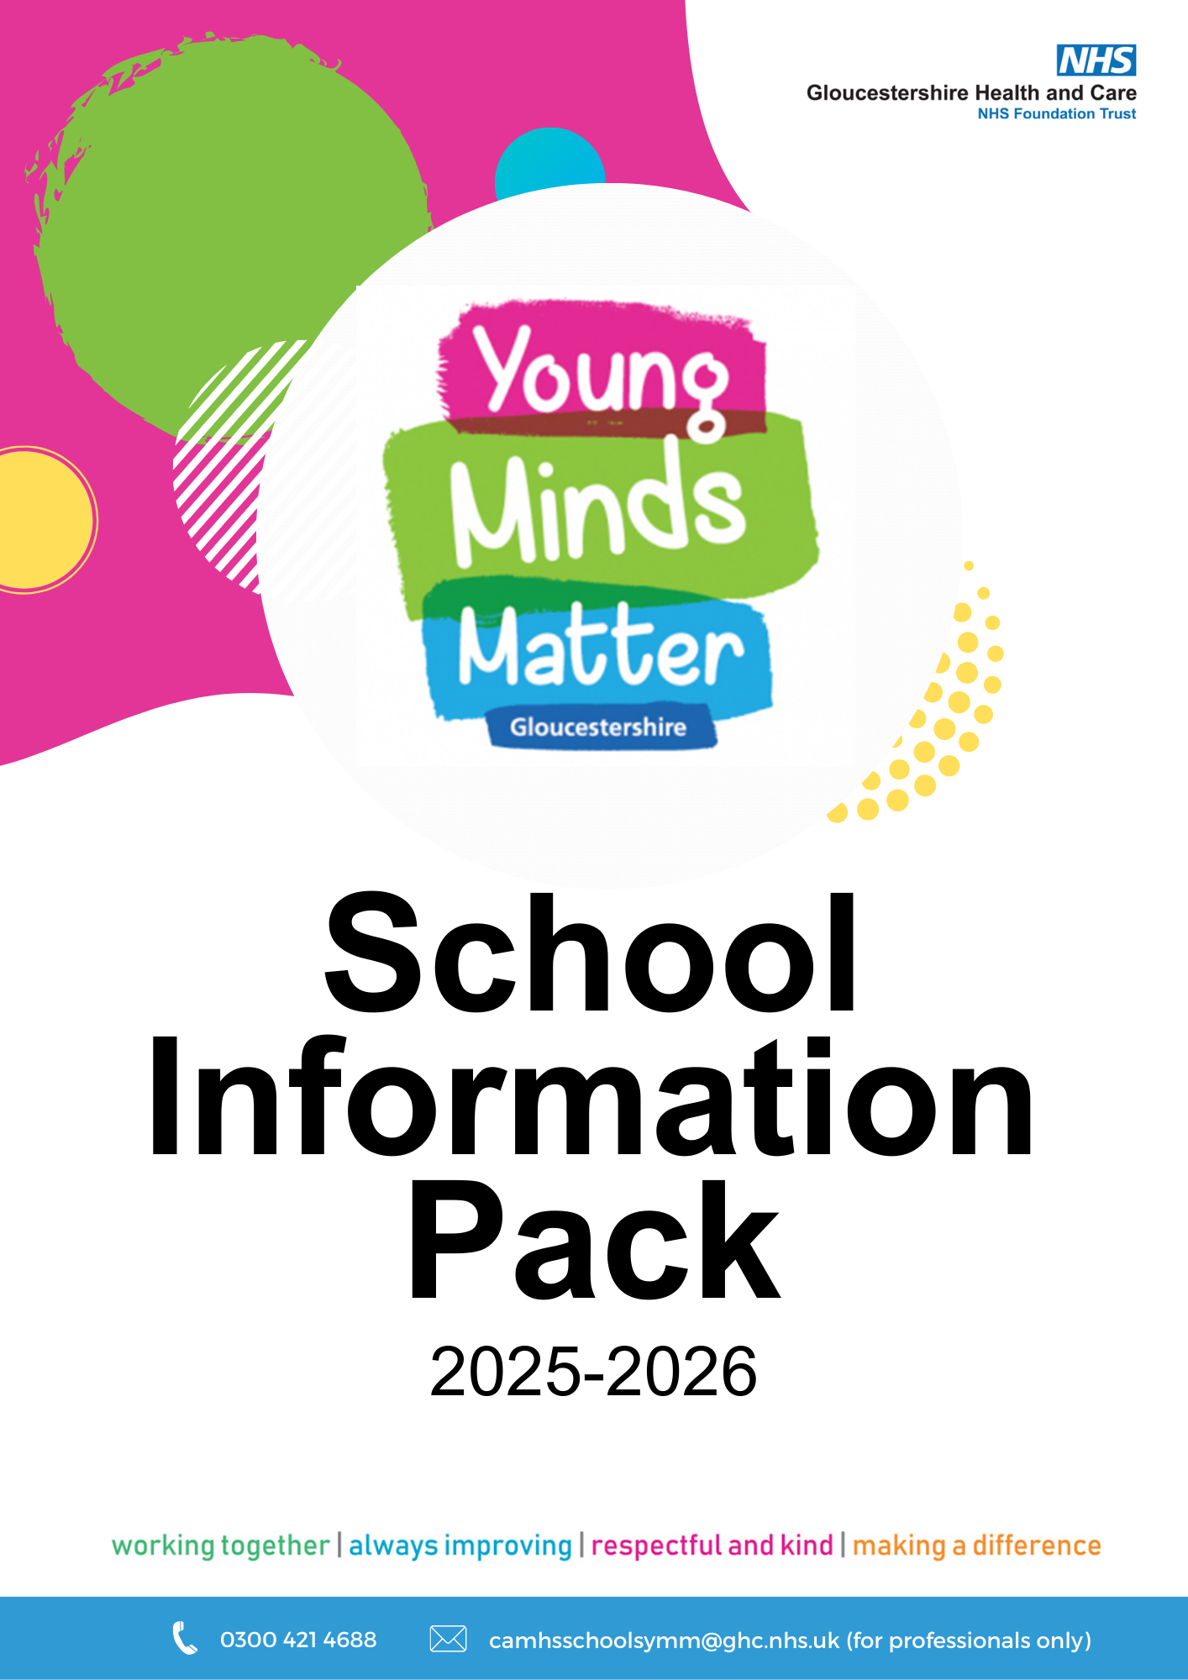

Who we are
Young Minds Matter is a Mental Health Support Team (MHST) that works across Gloucestershire. We are part of the Gloucestershire Health & Care NHS Trust and a national MHST scheme that emerged in response to the Government Green Paper for Children’s Mental Health in 2017.
The aim of our team is to help provide young people with early support to help them with mild to moderate mental health issues such as exam stress, anxiety or low mood. We do this by providing evidence-based interventions, advice & signposting through consultation and we support schools with the development of their Whole School Approach.
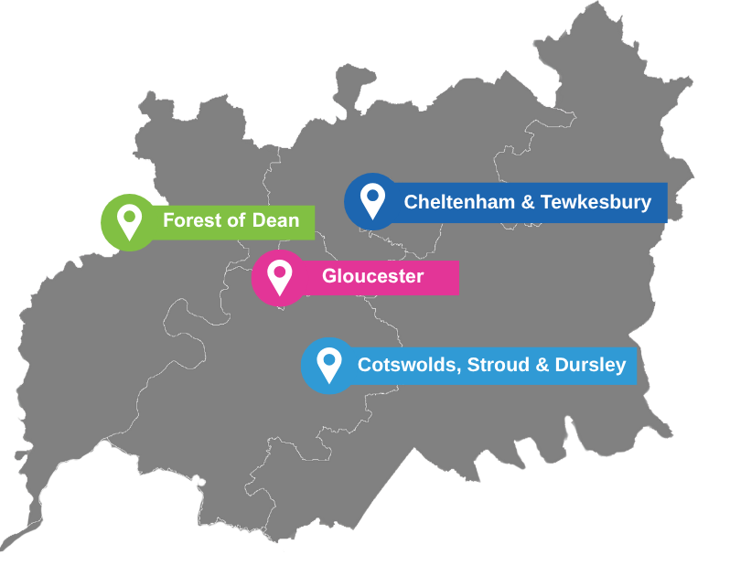
We have four teams in Young Minds Matter that are split by locality
but there is some cross-cover between teams. The Operational Lead, Clinical Lead, High Intensity CBT Lead, Whole School Approach Coordinator and Admin staff work across all four teams. We also have High Intensity Therapists that are based in Gloucester Locality only.

Each team includes:


Team Manager
Lead Senior Mental Health Practitioner (Lead SMHP)
Senior Mental Health Practitioners (SMHPs)
Education Mental Health Practitioners (EMHPs) / Children’s Wellbeing Practitioners (CWPs)
Whole School Approach Practitioner (WSA-P)

One-to-one Support
EMHPs and CWPs can support children and young people through a type of therapy called Low-Intensity Cognitive Behavioural Therapy (LI-CBT).
LI-CBT is a form of guided self-help, where we support children and young people to understand what is maintaining their anxiety/low mood and to find strategies to feel better. Sessions last for up to 8 weeks and usually run for 30-40 minutes. There are home tasks to be completed between sessions. Our Senior Mental Health Practitioners can deliver a more bespoke intervention.
We do not offer counselling and would refer on to our colleagues at Let’s Talk Well (previously TIC+) if we feel that counselling may be more helpful.

What is an EMHP/CWP?
Our EMHPs and CWPs provide 1:1 therapy in your schools. They are trained to deliver Low-Intensity Cognitive Behaviour Therapy, which is a form of guided self-help. Some of our EMHPs are also Supervisors that provide clinical supervision to other Trainee/Qualified EMHPs & CWPs. Some also provide consultation to schools, in the same way as SMHPs.

What is a SMHP?
Our SMHPs are practitioners who have a core profession such as a Nurse or Social Worker. They arrange consultations with schools to be able to give advice and guidance on support for students as well as the school’s Whole School Approach. SMHPs also carry out assessments and deliver 1:1 intervention if we feel the child/young person may need more support than Guided Self-Help.

What is a WSA-P?
Our WSA-Ps deliver our psychoeducation workshops, assemblies and other Whole School Approach related activities.
Referral Criteria
The table below gives you an idea of what type of difficulties Young Minds Matter can support with. We are unable to diagnose mental health problems or prescribe medication. We are also unable to diagnose or assess children and young people for neurodivergence.
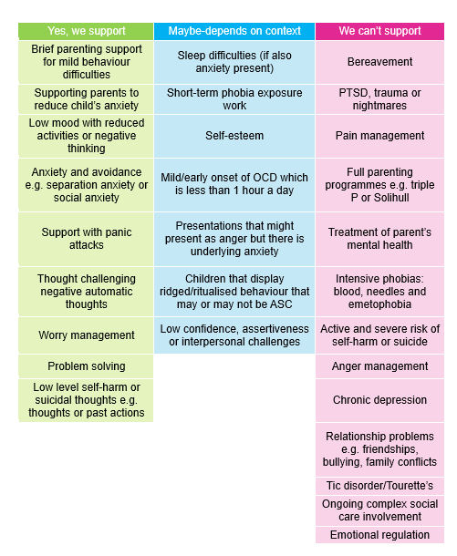

Referral Process
Discuss in consultation if remit feels unclear, for potential for referral or signposting.
Refer to Young Minds Matter using referral form link. We would recommend doing this with the child/young person or family.

Secondary school age children only:
Self-referral via Young Minds Matter Chat
(text base service)

School speak to young person/ family and discuss all presenting concerns.
Consider prior to referral:
- How long has the problem been present?
- How does this impact the child or young person (e.g. school, home, hobbies etc)
- Does it fit within the low-moderate criteria for intervention?
- Are there any systemic factors that need to be considered (e.g. bereavement or complex home circumstances)?
- What support has already been tried in school?
- Has all risk been discussed and safety planned before a referral has been made?

Young person/family speaks to school staff and shares concerns about emotional wellbeing and ask for help.
School notices a change in young person’s presentation/observes early warning signs.

Link to referral form (professionals only)
www.ghc.nhs.uk/our-teams-and-services/children-and-young-people/trailblazer-programme-request-for-support/
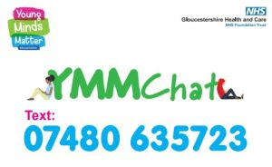
YMM Chat (self-referral)
YMM Chat is a confidential text service for secondary school aged young people to get advice or self-refer. The Chat is open Monday-Friday, 9am-4:30pm.
What to expect in an Assessment?
Please contact us if you would like a version of the below to show a child or young person.

Before the assessment
- An assessment will be booked with school by a member of our admin team.
- It will usually take place at school but could also be completed online or in a children’s centre.
- We will contact the young person and/or their parents/carers with the appointment details.
- We request that a parent/carer attends the assessment with their Primary School aged child. If they cannot attend, they need to give consent for us to see their child without them there.

During the assessment
- This is the child or young person’s space to share and an opportunity for the practitioner to get to know the young person.
- There will be questions from the practitioner for them to gain a better understanding about what is going on for them now, what is helpful/unhelpful, what they enjoy and what they would like to work on.
- We may offer all children and young people the opportunity to speak without a parent/carer present.
- Parents will be given an opportunity to share their worries or observations by phone if not able to attend assessment.

Assessment of Safety
During all assessments and interventions an assessment of safety will take place where we will ask about:
- Self-harm
- Suicide
- Harm from others
- Harm to others
- Alcohol and drug use
- Social media
- Any other behaviours that may cause harm
A “Just in Case Plan” is created with the child/young person, which they will have a copy of. The evidence base shows asking about suicidal thoughts or self-harm does not increase the likelihood that a child or young person will hurt themselves. We are aware that the language may need to be adapted to help a child or young person understand what we are asking them.
If we have concerns about a child or young person’s safety and feel that parents/carers and/or school need to be aware to keep the child or young person safe, then we will:
- encourage a child or young person to share the information or allow us to do this for them.
- ask them if there is a specific adult in school, they would like us to share information with. This is not always the referrer or safeguarding lead.
- highlight to a child or young people where a school policy regarding sharing might differ to ours and allow them to make an informed decision about sharing.
There are no specific criteria regarding what risk we would share with parents/carers; it is on a case-by-case basis, and we will use our internal policy and support structure within YMM to make this decision.

Assessment Process Overview
Referral to Young Minds Matter (YMM)
Referrals are screened daily

Liaison with referrer to inform of outcome or gather
more information if required

If appropriate for YMM we offer an assessment with an EMHP or SMHP.

Decision made at referral screening about which service may be appropriate (information held on our clinical system is also considered in decision making process)
Following assessment, we consider the best form of support
- LI CBT with an EMHP (up to 8 sessions)
- Bespoke support with an SMHP (6-8 sessions)
- Signposting or onward referral to another service
If appropriate for Let’s Talk Well (previously known as Tic+), we will send an onward referral using the details provided.
Assessment summary letter to be shared with young person and those where consent has been gained.
Outcome of assessment will be shared with referrer

2. Whole School Approach
A Whole School Approach to mental health looks at embedding principles of wellbeing into the whole of school life. Often, the school Mental Health Lead will lead on the Whole School Approach, but this may also involve other staff members at school and external partnerships.

Practically, this could include (but is not limited to):
- Ethos & Environment: Ensuring policies are in place to promote and celebrate diversity; engaging with whole school wellbeing events.
- Curriculum: Including principles of wellbeing across the curriculum, including but not limited to PHSE.
- Student Voice: Championing wellbeing ambassadors, school council and opportunities to feedback.
- Staff Development: All staff to be supported in undertaking training/CPD on a range of wellbeing/mental health topics.
- Identifying Impact: Using recognised measures of wellbeing to monitor impact of whole school interventions such as those found on the CORC website or Mentally Healthy Schools.
- Working with parents/carers: Holding parent/carer events and regularly asking for feedback
- Targeted support: Having a clear process for how staff can raise concerns. Staff noticeboard with all services that the school work with.
Whole School Approach activities don’t necessarily need to be additional wellbeing events. Your Whole School Approach is more likely to be sustainable when it involves the whole school community and activities that are already in your school life (e.g. school policies, Staff INSET day training items, pastoral support).
Young Minds Matter can support your school with your Whole School Approach by offering advice and signposting in our Consultations. We are also able to provide workshops/assemblies/small groups on specific topics. These are “one-off” activities, and you may wish to consider how you can use this as “springboard” to continue the theme for the remainder of the term. There is an expectation that the usual teaching staff would remain present in all YMM class workshops and assemblies.
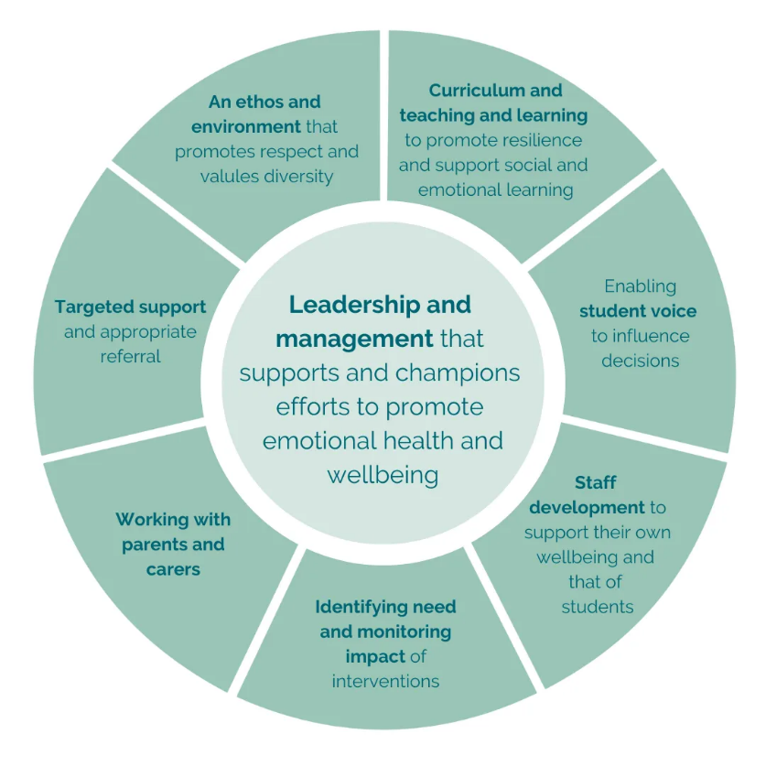
Our psychoeducation sessions are usually delivered by Whole School Approach Practitioners (WSA-Ps) but may also be delivered by other members of the team.
Taken from “Minds Ahead – Whole School Approach Graphic”

3. Consultation
Consultation is a space for the school’s Mental Health Lead and colleagues to meet with a Young Minds Matter practitioner. These usually last for an hour.
In Consultation you will have the opportunity to discuss topics relating to your school community. We can provide advice and guidance around issues relating to mental health that may be affecting your school community such as:
- Themes that are present within school (e.g. class or year groups).
- Themes that staff are noticing.
- Any wider community context that school are noticing.
- Support or referral for a specific child or young person you are concerned about.
- Understanding our referral process.

Expectations
We suggest that the school staff attending consultation have the time to fully engage in this space. We understand that many staff have lots of different roles and duties within their working week at school and we would like to be able to support them as much as possible with this.
To get the most from the consultation space it is helpful to be prepared. As a service we want to be able to offer the most appropriate advice and guidance to help see children and young people flourish.
Consultation is offered:
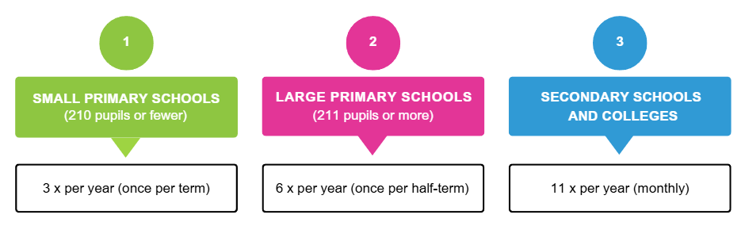

Support with your Whole School Approach
If you would like to book psychoeducation sessions, staff training, parent talks or pop-ups at school events then your aligned practitioner can discuss this during consultation and complete the booking form with you. They can also give advice and signposting around developing your whole school approach to mental health.

Discussing an individual child or young person.
Consultation can be used to formulate a child or young person’s current mental health difficulties. Formulation helps us gain better insight and a holistic overview of that child or young person. This may include discussing:
- The current situation: what they want help with, or what you are concerned about.
- Contributing factors: SEND or additional needs, what’s been unhelpful or helpful in the past.
- Current Impact: How is this affecting things in home, school and socially.
- What’s keeping the problem going: Family context, SEND, education/attendance concerns.
- What’s going well: What have school offered/are doing currently to support. Are there any other professionals involved.
- The young person’s voice.

Consent for discussion
The child and/or parents will need to be asked for their consent for this consultation conversation to take place, so that we can document the discussion on our clinical system for our records. To do this YMM will need the full names, date of birth and post code of all children that you may wish to discuss at Consultation.
If you are unable to gain consent from the families to discuss a child or young person, we can still discuss them and offer advice and guidance however this will be on a ‘no name basis’. We understand that sometimes the opportunity to discuss a child or young person may come at short notice.
The outcome of the discussion could be:
- Signposting to other agencies.
- Advice / strategies / resources
- Referral to and/or advice from CAMHS: referrals will be completed by Schools (with support from aligned practitioner if needed)
- Referral into YMM: referrals to be completed by school following consultation.
- TAF/TAC/TAS: Your YMM practitioner can attend and contribute to meetings on behalf of YMM/CAMHS.

