Ormiston Shelfield Community Academy have revitalised their PSHE provision for Key stages 3 & 4 this academic year.

Their overriding aim being to ensure delivery of a broad and balanced curriculum. The programme described below is part of a three year PSHE development plan.

The new programme is delivered by form tutors in the 25 minute morning tutor slot and therefore materials are designed to introduce concepts and issues in a fast paced, engaging way.

The materials provided here have been developed by Carmel Tatlock, Curriculum Enrichment Leader at Shelfield. Carmel has based her resources on the Easy SRE films: Help I'm Hairy, Notes to Self and Tell Me More. The resources are comprised of a student wokbook and accompanying PowerPoint presentation for each film which deliverers can use to lead them through each unit.

At Shelfield each PSHEE unit is delivered over 5 weeks in 3 sessions per week and so each resource pack provides 15 discrete sessions.

Please feel free to adapt and use these resources as fits your organisation’s needs.

For further support and information you can make contact with Carol Williams carol.williams@walsallhealthcare.nhs.uk or Carmel Tatlock postbox@scacademy.co.uk

Year 7
Personal, Social, Health & Economic Education
Core Theme 2: Relationships

This booklet belongs to:

1 Getting to know each other

Learning Objective:
- To develop the skills and knowledge required to manage the transition to, and the expectations of, secondary education
Success Criteria:
- Students engage with each other and their form tutors to get to know each other
- Students can communicate effectively and listen to others

PEOPLE SEARCH
Find 9 different people in the class who fit the following descriptions and write their names in the boxes.
Find someone who has lived in a different country. Which one? | Find someone who plays a musical instrument. Which instrument? | Find someone whose favourite sport is football.
Find someone who stays up late at night. | Find someone who collects something. What is it? | Find someone who loves vegetables.
Find someone who owns an unusual pet. What is it? | Find someone who isn’t frightened by spiders! | Find someone who doesn’t watch the ‘X’ Factor when it’s on television.
My Tutor Group
I introduced ……………………………………………………………………………………………………………………… to the group.
I spoke to …………………………………………………………………………………………………… who I had not met before.
My first impressions of my tutor group are ……………………………………………………………………………………………………………………………………………………………………………………………………………………………………………………………………………………………………………………………………………………………………………………………………………………………………………………………………………………………………………………………….
2 Changing schools / New beginnings

Learning Objective:
- To develop the skills and knowledge required to manage the transition to, and the expectations of, secondary education

Success Criteria:
- Students take part in a discussion about how they felt about moving schools and to talk about their concerns in a positive way
- Students express their emotions clearly and openly

For most people, starting Shelfield Community Academy was probably quite nerve racking. For some people it will have been their first change of school.

Hands up survey (Record the results below):
Question | Number of people
How many people have never changed schools previously?
How many have changed schools once?
How many have changed schools twice?
How many have changed schools more than twice?

Question: What were you most worried about starting at Shelfield?
Problem | Solution
 |  | Least worried about Most worried about
In 2-3 sentences write down what you had worried about the most and how you will deal with it now

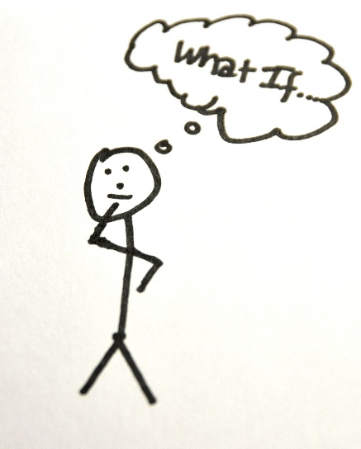
3 Being a Newcomer – What happens if….?

Learning Objective:
- We are learning how to identify and access appropriate advice and support

Success Criteria:
- Students know where they should go or what to do in a range of situations
- Students are aware of feelings of anyone who is still finding it difficult to settle in and have discussed ways to support each other

In a new school there seems to be so many things that puzzle you. In a few months you will have forgotten them, although they were important at first. It is useful to think about these situations and discover that you already have a good idea about coping with them.
Working with a friend decide what you would do in each of the following situations:

The Situation | What would you do?
1) You have been sent on a message but you cannot find the person for whom the message is intended

2) You have fallen in the playground and hurt your wrist. It is not very swollen but it is very painful

3) You have lost your new jacket at lunch, it has your name in but nobody has seen it

4) You have been asked for £1 by a boy in the playground. He asks you every day but he has not threatened you at all
5) You have been having fun running around on the field with your friends. Suddenly you hear a rip, your friends laugh and you realise you have split your trousers.
6) Your bus was late, it wasn’t your fault. Registration has finished – what do you do to get your mark?

7) You have noticed that a friend is being called names by a group of other students. Your friend is upset but is frightened to tell anyone
You have left your school shoes at your Nan’s house over the weekend and have had to come to school in your trainers
You have forgotten your lunch money

Who can I turn to for help?
Role | Name | Where are they?
Year 7 Year Progress Coordinator
Year 7 Guidance Manager

Welfare Manager

Mentor & Counsellor

SENCO

Learning Support Assistants
Form Tutor

Peer Mentor

Student Reception

Who are my subject teachers?

Subject | Teachers name
- English
- Mathematics
- Science
- History
- Geography
- Religious Education
- Music
- Art
- Modern Foreign Languages
- Physical Education
- Technology
- Drama
- ICT
- History

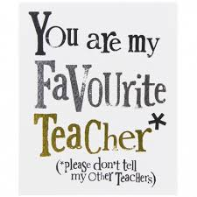

4 This is me!

Learning Objective:
- To develop the skills and knowledge required to manage the transition to, and the expectations of, secondary education
- To introduce yourself to your form group

Success Criteria:
- Students evaluate the sort of person they are and to gain confidence in talking about themselves
- Students recognise that they are a unique individual and think about themselves on many different levels

5 Yourself as others see you

Learning Objective:
- How to develop and maintain a variety of healthy relationships within a range of social/cultural contexts

Success criteria:
- For pupils to investigate their own view of themselves and compare this with how others see them
- To help pupils recognise when they should feel pleased with themselves

Adjective rating list!
Use the rating of: Always Occasionally Often Never

SELF | ADJECTIVE | OTHER
 | 1. Friendly
 | 2. Aggressive
 | 3. Selfish
 | 4. Couldn’t care less
 | 5. Hard working
 | 6.Adventurous
 | 7. Shy and quiet
 | 8. Reliable
 | 9.Enthusiastic
 | 10. Easily bored
 | 11. Easily led
 | 12. Nosey
 | 13. Amusing
 | 14. Patient
 | 15. Fashionable
Did you see yourself in the same way as your partner did?

What did you agree about? What did you disagree about?

Compliments

Now that we know each other better…
Write down everyone’s name in the room and next to it write one NICE thing about them

Name | Compliment

Write down a quality that you have heard given to another person that you wish you had.
How could you develop that quality? What do you need to work on to be more that way?

6 Friendship
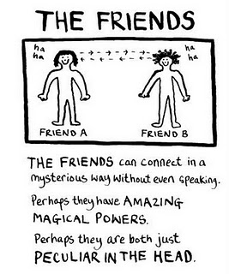
Learning Objective:
- To explore how friendships can change and develop or end

Success Criteria:
- All must identify the qualities of a good friend
- Most should describe how friendships can change over time
- Some could offer advice to their peers on how to cope with changing friendships

Circle of Friends

In the circles list all your friends

In the closet circle to the centre put your best friends

Work your way outwards with other friends, people you get on with to acquaintances

Discuss – how have your friendships changed since you have started at Shelfield?

Has this been easy or hard?

Friendship quiz

1. You are with a friend and they say something you do not agree with. Do you...  a) agree with them to avoid an argument  b) only say what you think if they ask your opinion  c) tell them you don’t agree with them and explain why? | 4. A group of friends are teasing someone and making hurtful remarks about them. Do you...  a) join in because they expect you to do so  b) not join in, but do nothing to stop them  c) try to get them to stop? | 6. Two of your friends have a row and fall out. Do you...  a) take the side of the person you like best  b) leave them to sort it out and try not to get involved  c) listen to both sides and support whoever you think is in the right?
2. You have become friends with someone none of the rest of your friends like. Do you...  a) drop your new friend  b) ask your friends why they don’t like your new friend then decide what to do  c) tell them that it’s none of their business and you’ll be friends with who you choose? |  | 7. One of your friends asks you to tell a lie to stop them getting into trouble with their parents. Do you...  a) agree to do so because you are afraid of losing their friendship  b) say you’ll only do so if you are not covering up anything serious  c) say no and explain that you can’t get involved in what’s going on between them and their parents?
3. Some friends dare you to do something reckless that could have serious consequences. Do you...  a) agree to do it in order to try to impress them  b) find an excuse for not doing it  c) refuse and say you’re not prepared to be so reckless? | 5. Your friends ask you to do something that may get you into trouble with the police. Do you...  a) join in because everyone else is  b) try and persuade them it’s wrong, but go along with them if they won’t listen  c) tell them you’re not joining in and walk away? | 8. You friends are talking about sex in a way you don’t like. Do you...  a) join in, even though you feel uncomfortable  b) keep quiet, but not show your disapproval  c) tell them why you don’t like the way they are talking?

What are the outcomes of the quiz?

Would your answers change if you were thinking about a different set of friends? Why would they? How can different friends make you act in a different way?

Friendship mind map – use the questions below to help you to organise your thoughts

- What qualities do you look for in a friend?
- Are friends more important to you now than they were in primary school? Why?
- What's the difference between a friend and an acquaintance?
- How do you tell the difference between true friends and false friends?
- What is a "best friend?" Is it possible to have more than one "best friend" at the same time?
- In what ways does friendship change as you get older?
- Is there a difference between popularity and friendship? Can you be popular and not be a good friend? What is more important, being popular, or being a good friend?
- Describe the groups or cliques that people you know associate with. Are the relationships within these groups real friendships? What's the difference between friendship and group membership?

Is it ok to change friends? What do you think?

What things do you need to be able to do to make changing friendships less stressful for each other?

How can you look after each other?

What makes a good friend? List the qualities that you think you would like in a good friend in the thought bubble

A Good Friend is…

Advertise yourself announcing your qualities as a potential friend. Your advert can contain drawings, phrases or anything else to get the message across about the personal qualities you can offer in friendship. The content can contain the sort of person you are as well as hobbies and interests. Can you come up with a slogan to sum you up – ask a friend for ideas

7 Relationships

Learning Objective:
- To recognise different types of relationships, including those within families, friendships, romantic or intimate relationships and the factors that can affect these (including age, gender, power and interests)
- To recognise the qualities and behaviours they should expect and exhibit in a wide variety of positive relationships (including teams, class, friendships etc.)
- To explore the range of positive qualities people bring to relationships

Success criteria:
- Students will take part in a series of discussion activities reflecting on a range of different relationships
- Student offer suggestions the good things about relationships and what can be difficult about relationships

In pairs, write down as many different types of relationships that you can have with other people that you can think of

Is there a difference between a relationship and a friendship? What are the differences?

Can you think of someone who you get on really well with and you enjoy having a relationship with them. What kind of things makes it an ‘easy’ relationship?

Can you think of someone who you don’t get on well with and you don’t enjoy their company. What kind of things make it difficult?

Can you think of someone who you are ‘attracted’ to? What kind of things attract you to that person?

Romantic Relationships
Why do you think we need these kinds of relationship?

What do we get out of these types of relationship?

What do you look for in a partner?
Try to think of think of things other than looks....the novelty of looks can soon ware off if you have nothing in common etc. Note down 9 traits that you would like a partner to have

Rank your chosen traits in the following order of importance

1

2 2

3 3 3

4 4

5

I think that the most important trait in a partner is

Because

I think that the least important trait in a partner is

Because

Why are close relationships important?

What can make close relationships difficult at times?

Why is good communication important within a relationship?

How important do you think commitment and fidelity is in a serious relationship?

Relationship jigsaw: Write key words or statements that you think describe what a good relationship would have e.g. Good communication, fun, etc. Think of it as a relationship recipe!
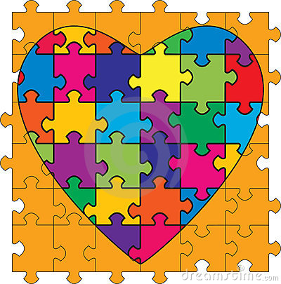
A successful
relationship
8 You and Your Family

Learning Objective:
- To consider the roles and responsibilities of parents, carers and children in families
- To see the world from other people’s points of view

Success Criteria:
- Students can describe and understand some common sources of conflict in families
- Students can suggest ways to improve relationships at home

Starter

What causes arguments at home?

Read the letter from Laura

I need my own space!

Please help – my mum and dad are driving me up the wall. I’m 11 and have my own bedroom, which would be great if my parents weren’t coming in all the time and hassling me. Sometimes I get back from school and all my stuff’s been moved around so I can’t find anything I want. My mum says she’s just tidying up but it really bugs me – she even threw away some old magazines I’d been saving the other day! I know it sounds horrible but it feels like she’s spying on me. My dad’s just as bad – he’s always coming in and trying to talk to me, when all I want to do is lie on my bed and listen to music. He doesn’t even knock before he comes in. I’ve tried putting Keep Out signs on the door but they just laugh and don’t take any notice.

Laura, Manchester

Think about Laura’s problem in pairs. What advice would you offer her?

How are her parents likely to be feeling?

Maybe their behaviour is no different to usual but now that Laura is growing up it’s her that’s changing not them. How do they deal with this?

Read the advice letter do you agree?

Advice to problem:

- Everyone has a right to privacy but try to remember it can be hard for parents to accept that you’re growing up and need your own space.

- You may find at first your parents don’t really take your need for privacy seriously so it’s important to go about things in the right way. Putting up signs like Keep Out or accusing them of spying will only annoy them and make you seem childish. You need to explain your point of view calmly but firmly. Tell them you still love them loads but you would appreciate a bit more privacy now that you are getting older.

- Show your parents you’re growing up by agreeing to take more responsibility for tidying your own room - that way your mum will have less excuse to go in there! It’s also a good idea to keep talking to your mum and dad about what’s happening in your life. If you’re secretive and act like you have something to hide then they’ll be more tempted to look around your room to find out what’s going on!

Talking is always important and once you put up a wall between you and the adults in your life it can be more difficult and lead to even more problems in the future
Do you help at home?

Many arguments between children and parents are about the way you behave at home. Many adults feel that everyone living in the family group should do their fair share of the household chores. What do you think?

How often do you help with the following activities: a) daily, b) two or three times a week, c) once a week, d) once a month, e) hardly ever, f) never

Activity | How often do I help?
Cooking
Hoovering
Dusting
Cleaning
Making beds
Washing up/loading the dishwasher
Washing clothes
Ironing
Shopping
Setting the table
Clearing away
Cooking
Cleaning the car
Gardening

What else do you help with that isn’t on the list?

Write a short statement of the reasons why children should/should not be expected to help with household chores

Getting on better with Adults!

Think back over our last few sessions. Make a poster or charter for display, entitled ‘Top ten tips on how to get on better with the adults in your life’. You can use the space below to draft your ideas.

Plenary

Decide on one piece of advice you have written or discussed and decide on one thing that you are going to make more effort with at home from TODAY!

