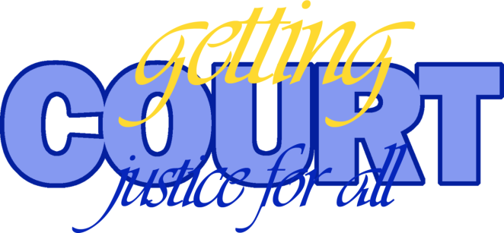

Contents
Introduction

Acknowledgments

Overview

Lesson 1: What happens if you have to make a choice?
Help pupils recognise that many people can influence our decision making, and that the choices we make can have potentially far-reaching impact on our-self and others.

Lesson 2: What happens if you break the law?
Students are encouraged to look at crimes and establish how serious they are. They also look at what happens to an individual who is suspected of committing a crime. They look at rights and the impact of crime on our society.

Lesson 3: What happens if you have to speak up?
Pupils look at their civic responsibility to speak out whether a victim or a witness to a crime. They are also to consider the barriers that can often prevent people speaking out, and look at what is in place to help people.

Lesson 4: What happens if you are found guilty?
Pupils look at different punishments commonly used in the UK and their effectiveness.

Lesson 5: What happens if you visit a court?
Pupils explore the functions and roles of the key people in our legal system and are introduced to some key legal terms.

Information for teachers:
A school visit to Gloucestershire Crown Court.

Summary of resources

Assessment for learning ideas

Other useful resources and websites

.

