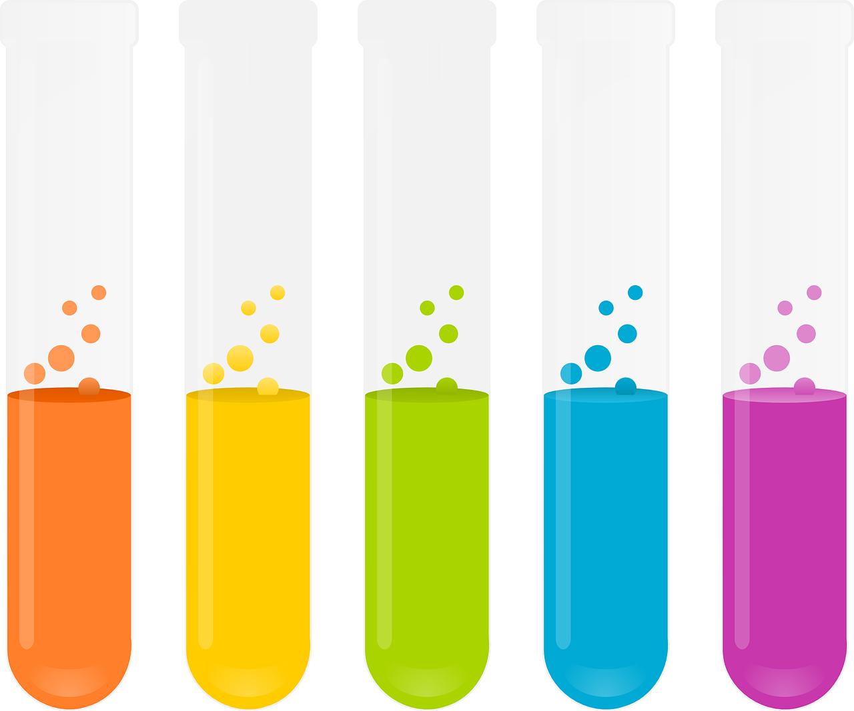

**Cortisol** is one of the chemicals that is produced when we feel stressed and anxious. Cortisol produces glucose which is needed if you are going into flight or fight. It also stops us from having the ability to think logically. Again, this is important in the flight or fight response as it ensures that you act instinctively and quickly!

It is not so good at times like this when we all feel anxious

**Serotonin** important for regulating mood, happiness and sleep. Serotonin is also important to help us reach the optimum state for learning.

**Oxytocin** is important for relationships as it increases feelings of trust and generosity and increases behaviour that strengthens relationships. Oxytocin is also important as it decreases feelings of anxiety especially at times of heightened fear.

**Dopamine** supports our ability to think, focus and find things interesting. It is linked to feelings of pleasure and motivation. Dopamine is important for our heart rate, blood vessel functioning, kidney function, sleep and mood.